Appendix 2
The Cole-Hackenberger Motor/Engine Prototype Timeline 1957 – 1989

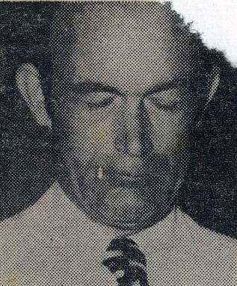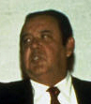
Richard Hackenberger “Hack” E.V. Gray Nelson Schlaft “Rocky”
1973 1976 (at 51) 2007 (at 66)

This paper is a collection of photos and information to help interested researchers follow the 30 year saga of E.V. Gray and his Free Energy adventures. The focus is on the sequential development of 15 extraordinary machines. It is intended to help sort out the evolution of this technology and hopefully aid experimenters in their quest to successfully reproduce this exotic equipment. The surviving technical history is spotty, thus the author has filled in a multitude of holes with plausible & creative speculations. Many of the photos presented have only become available in the last few years through the generous contributions of individuals who have become willing to share their stories and private collections of memorabilia.

It is presently thought that, in all, 15 motors/engines were made at a cost in excess of a $1-1/2 million (in 1970 dollars). It is still undetermined just where all this money came from. It is thought that there were some ancillary devices developed along the way that were quite impressive in their own right (The Electrostatic Generator and Military Mortar) that helped convince potential investors as to the feasibility of this endeavor. As for the Motors/Engines there were two distinct eras of development: 1) The Pulse Motor development phase (1957 – circa 1964) and 2) the Free Energy Engine phase (circa 1965 – 1979).

A fair amount of circumstantial history has been folded into this commentary in order to help explain how things went the way they did. A lot of engineering decisions were based upon finances and the prevailing marketing conditions. There is a lot of supplemental speculative technical information available to the reader on the Internet. Those specific topics can be better appreciated after the whole history of this technology is examined.

Summary of the Cole/Hackenberger Motor/Engine Prototypes:

Model Year Engineer Case Feature Demise
(Circa) Size

Pulse Motors
E0 1961 Cole 9” First Motor to operate ? Thought to be in storage
E1 1963? Cole 12” “Brown Motor” Owned by Alan Francoeur
E2 1963 Cole 12” “Purple Motor” Owned by John D. Riley
E3 1963 Cole 12” 3-Pole Case only Owned by Mark McKay
E4 1964 Cole 12” Single Pole test Motor Owned by Alan Francoeur
E5 1964 Cole 12” All non-conductive construction Owned by Alan Francoeur
E5A 1966 Cole 12” All non-conductive construction Destroyed by DA in 1974

Free Energy Engines
EMA0 1970 Cole 3” Mock up model (non-functional) Owned by Mark McKay
EMA1 1967 Cole 12” First true Free Energy Engine ? Probably cannibalized
EMA2 1969 Cole 12” 10 HP tested by Crosby Research Destroyed by in 1974
EMA4-E1 1970 Cole 16” 32.5 HP automotive engine Upgraded to EMA4-E2
EMA4-E2 1973 “Hack” 16” Upgrade of EMA4-E1 to 100 HP Destroyed by DA in 1974
EMA5 1973 “Hack” 12” Case only – Engine never completed Destroyed by DA in 1974
EMA6-E1 1974 “Hack” 12” Failed new generation design 2 HP Upgraded to EMA6-E2
EMA6-E2 1976 “Hack” 12” Retrofitted EMA6 Destroyed by FCC in 1979
EMA7 1979 “Hack” 9” Built in Kalona, Iowa “Blue Engine” ? Thought to be in storage

The Capacitor Discharge Pulse Motor Phase (1957 – circa 1964):

Marvin Cole and E.V. Gray were friends and neighbors living in Los Angeles. Cole was a single man who made a good living as a chef at an upscale seafood restaurant. Gray had been a lifelong auto-body-fender man and known to be quite good at the craft. In 1957 a Russian emigrant named Andre Poppoff gave a “Popping Coil” toy setup (or at least the plans to one) to Mr. Gray, who then got the idea of using this device as the basis for a new kind of motor. He brought his idea to Mr. Cole, who held a masters degree in mechanical engineering and was exceptionally skilled at technical illustration. The two then began drawing sketches in the living room and hatching plans to build an industrial motor that would (hopefully) be more efficient than common motors and could produce huge torques at low speeds with out excessive heat. They started out exploiting a novel combination of common classical processes intending to create this new and improved motor technology. About a year later Mr. Gray had to leave town because of unpleasant business issues. Mr. Cole appears to have continued working on the project by himself. In 1964 there was a major shift in the direction of development. Mr. Gray, soon there after, managed to move back to Los Angeles and re-partner with Cole for a venture that was promising to be much more interesting and potentially very lucrative. It is thought that the 3-Pole motors (E0 to E5A) were made from 1961 to about 1964. Originally they were intended to be development prototypes that were incremental exploration steps in working out the engineering details of their new pulse motor concept. However, something happened along the way that changed the story and could have well changed western history as we know it (But that’s another story).

The Free-Energy Engine Phase (circa 1965 – 1979):

In 1964, while Gray was living in Las Vegas, he received a kit of parts (assumed to be from Marvin Cole) that he assembled outdoors between two buildings. The purpose of the electrical hardware was unknown to the family. Some tests were conducted, but the result was an explosion of some kind that abruptly ended the experiments. This has been speculated to be a hydrogen explosion from an over charged lead-acid battery. No injures were reported. The sons were tasked to clean up the fragments of a damaged car battery (with its top blown off), some magnet wire, an ignition coil, some white plastic pieces, plus a small assortment of other un-familiar components. The same year Mr. Gray moved back to Los Angeles and the quest for Free Energy was apparently begun in earnest, in secret, and unknown to his family. It is assumed that the first over-unity observations took place in 1964 when Cole was working alone with on one of the 3-Pole motors. It is speculated that Mr. Cole, while improving on the Pulse Motor design, some how observed that his energy efficient motor was indeed so efficient that it was generating more output speed and torque than what it should have been - based upon the amount of electrical energy that was being supplied to it. Experiments and modifications were made to understand and enhance the process. It is not known just which 3-Pole Pulse Motor provided the first evidence of the Free-Energy phenomenon, but it is assumed that it was the last one of the 5 model E series (the E5) where Mr. Cole explored an all plastic (non-conductive) construction.

From here the outrageous technical adventure began. The design of the Motor shifted from a 3-Pole single coil design to a 9-Pole dual coil design and was from then on called an engine. Much of the architecture of the previous Pulse Motors remained. The new non-classical process was studied for a few years and this is how the true Free-Energy Engines came about. Apparently even the first prototype of the new design met with success. The10 HP second prototype of this series (EMA2) was evaluated by a 3rd party testing organization that yielded some fantastic results. The next advancement goal was to increase the horse-power output of the engine to 100 or 200 HP thus building a model as powerful as a gasoline automotive engine. Then suddenly, in 1972, Marvin Cole left the project, never to return, after signing over his interests to E.V.Gray (for a fee?). He left town with his pregnant girl friend and never came back. It is speculated that he had developed a serious anxiety complex concerning the power of the processes he had discovered. His attitude took a sudden change when an associated anti-gravity phenomenon became apparent in addition to the vast over-unity effects. After that he feared of being commandeered by the government or some other hostile cartel. From then on Gray, not suffering from the same concern (at the time), carried on attempting to further develop and sell the technology using hired specialists to take Cole’s place. Gray’s technical knowledge of the physics and electronics of this invention was quite limited, thus for a long time, the actual technical progress came to a standstill.

The “EMA” in the model number of the Free Energy Engine series stands for “Electro Magnetic Associates”, which was the group of “insiders” that were the funding source for this effort from 1962 to 1972. Originally the name was ESMA which stood for Electro Static & Magnetic Associates. The S was dropped to help cover up the major non-classical process involved. This funding group was disbanded when Mr. Cole left and Gray took total control of the project and reorganized it under his own business name Zetech.

Shortly after Mr. Cole’s departure, Gray hired Richard Hackenberger, a solid state electrical engineer from Silicon Valley. It seems to have taken Mr. Hackenberger a few years to decode just what Cole had done, even with working prototypes in front of him. He made some understandable mistakes, but seems to have eventually rectified his misunderstandings and eventually make improvements, however in 1980 he died before any of his work could reach fruition. Gray continued for the rest of his life attempting to profit from all this development, without much success. It seems that he never did develop a full technical understanding as to how these engines actually worked. He died in 1989, in Sparks Nevada, from a stress induced heart attack. By then he was in poor health and had developed a serious anxiety complex of his own, with good reason, since hostile individuals were pressuring him with threats to hand over the technology.

Reincarnation of the E-Series Pulse Motor Prototypes

Back in 1980, while attempting to create promotion videos to sell this technology (off shore), Gray recovered many of the Pulse E-Motor prototypes from storage and hired a technician (Nelson Schlaft) to get them to run – somehow. Mr. Schlaft was able to accomplish this task, but the results were far form a Free-Energy solution. The modified motors now required huge amounts of power to rotate with no load, but they could now start from a dead stop and could run in both directions – which is something that the original E-Motors couldn’t do. Never the less Gray made videos of these operating machines and passed them off as working Free-energy engines using the 1973 test results from the EMA2 engine as verification. Apparently this approached worked since Gray was alleged to have amassed a $27 million dollar investment fund (according to the company lawyer Joe Gordon) through a Cayman Island brokerage firm. Gray was later swindled out of this money.

The remodeled Pulse E-Motors were re-named according to the dominate color of their case or decoration during the 1980 retro-fit when they were being converted into stage props. Thus the “Black”, “White”, “Purple”, and “Brown” designations came into being. Gray probably allowed this conversion to take place since these motors were not the successful Free-Energy Engine designs anyway. But they looked just like the real thing and would serve well for operating video mockups for almost no cost.

The E series Pulse Motors are numbered according to digits stamped on the motor cases. These have been observed for the E1, E3, E4, and E5. The E2 motor has not been examined (requires disassembly) but is assumed to be the “Purple Motor”. This is a fair guess since the “Purple Motor” and the E1 (“Brown Motor”) are so close to each other in external appearance. It is speculated that these most of these models were heavily modified and rearranged a number of times by Cole as he attempted to get his arms around the observed Free-Energy process.

It is reported (from Mark Gray – E.V. Gray’s 4th son) that when these E motors were first retrieved from storage in 1980 that most of them lacked power supplies and a majority of the ancillary switching systems (assumed to the Thyratron systems). It is thought that Cole kept migrating these sub-system components from motor to motor, rather than building new ones for each test bed. This was probably done for financial reasons since the custom made mica storage capacitors and special order high voltage transformers were expensive and had a long lead times.

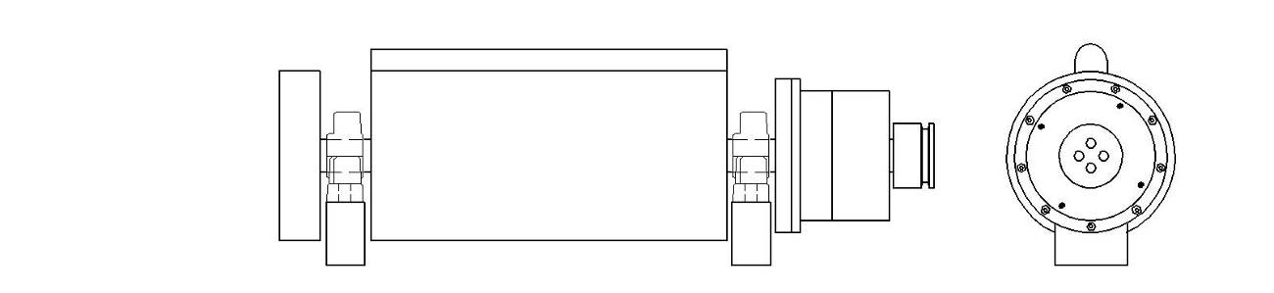
This sketch is assumed to be of the first operational Pulse Motor and is identified as the E0

E0 - 3 Pole Motor (1961)

It is not known for sure, but the motor and stand shown on the far right of the E-motor family photo (below) is thought to be the E0. It has a smaller case (about 9” diameter) and is therefore assumed to be a logical starting point for new development exploration. If so, then the tests conducted with this early motor pointed to the need for a larger diameter case (12” diameter), which then became a standard for the rest of the E-Motor designs. The 8” x 4” white cylinder at the end of the motor is a rotary mechanical switching system (called a commutator). The design of this sub-system remained pretty constant (externally) throughout the development of the E-motors and is a prominent feature in the later Free Energy Engines.

Cole must have starting receiving some external development funding shortly after building the E0 motor. The cost and complexity of the later machines would have been well beyond the means of even a well known chef. Apparently there was some sort of venture capital available in LA to advance the idea of a novel high torque industrial pulse motor.

In early tabloid interviews (1973) with Gray, described how the first motor operated for a few minutes in 1961. Gray was not in California at that time nor was he working on motors, so this date is probably when Cole was able to get his first prototype to run. We don’t know what Cole’s funding situation was at the time, but if he only had his income from being a professional chef, (At the “Grotto” on pier #57 in LA) then it probably took him about two years to just to pay for the parts (in cash of course). This kind of work is beyond the capacity of what can be done with hand tools or with common shop power tools. The construction of precession rotary apparatus requires the services of a machine shop. Since there are hundreds of parts that went into the construction of the later engines, it is thought that it was not much different for the first prototypes. The good news is that Cole must have seen some potential in this first expensive experimental model to continue on to finance and build the E1 motor. It is estimated that Cole spent as much money on this first prototype as one would lay down on a new mid-range fully loaded car.

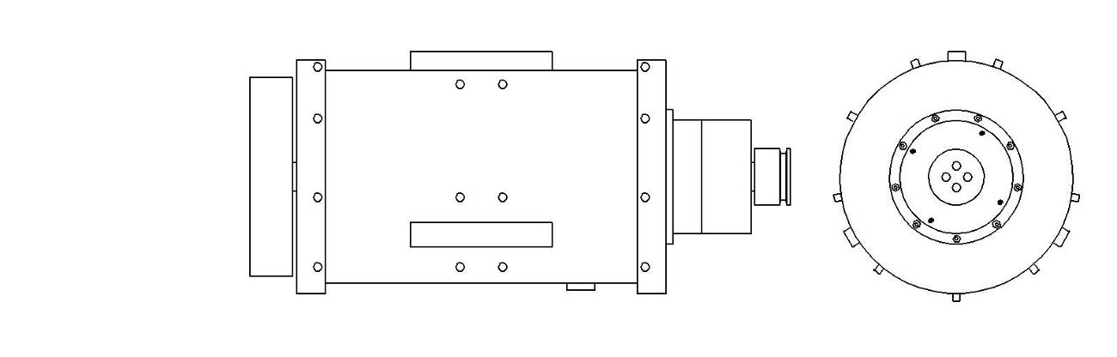
E1 – 3 Pole Motor “The Brown Motor” (circa 1963)

In October 2010 John D. Riley of Canyon Country, CA generously provided the common domain a most interesting series of high quality photos of the E1 aka “The Brown Motor”. His intent was to offer this piece of history to the highest bidder starting at $30,000. This motor was acquired by Mr. Al Francoeur of Yhak, BC to add to his unique collection. Unfortunately, this motor, along with the rest of the E-series motors were retrofitted in 1980 by Nelson Schlaft. Whatever over-unity construction it originally contained, has long since largely been removed. Darn!

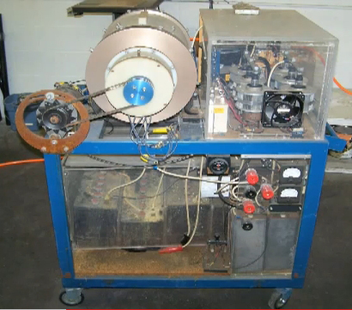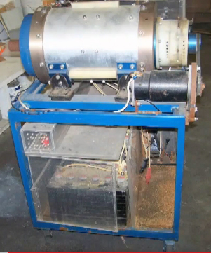

2010 Photos of the E1 aka “The Brown Motor” by John D. Riley offering this piece of history for sale to the highest bidder for a minimum of $30,000. It appears that this experimental test bed has been well stored for the past 24 years. The clear Plexiglas box on the side that houses the six ignitrons once contained Marvin Cole’s approach to switching the output pulse of the storage capacitors. There is some evidence that he employed thyratrons at this stage, but then was able to use another method for later models.

The “Brown Motor” seems to be the first in a series of five very similar experimental prototypes. It has the large external end plates (assumed to be solid aluminum) rather than the internal design seen in the later E4 and E5-A. This aluminum case seems to be even thicker than the plastic case of the E5. The commutators of all the Pulse Motors seem identical from their external appearance. The shaft, the electromagnets, the internal slip ring assemblies seemed to have been copied from a common design that was used for the rest of the Motor family. The large insulating sleeve around the steel shaft of the E1 is a feature that carries through the other Pulse Motors. Because of many auxh similarities it is thought that these motors were fabricated in one relatively short span of time (a year?). Nelson Schlaft reports that his boss E.V. Gray told him that each motor was designed to explore/display a particular aspect of this technology. It is likely that the drawings that were sent to the machine shops for fabrication quotes were used over again for this Pulse Motor series. The plans were probably not modified until absolutely necessary.

The end view below, of the stator electromagnets, shows scant insulation between the case and the stator electromagnetic cores in this initial design. This suggests that whatever potentials existed between the cores and the case were not extremely high. The thickness of the white insulation sheet material used in the E1 is the thinnest that will ever be seen in this technology. From here on there is a steady progression in greater electrical isolation between the motor internal components and the case. This early design was provide with substantial insulation on the shaft since the 0.250” white plastic (nylon?) shaft sleeve can be clearly seen in the photo below.

All of the electrical components (Ignitrons), that are stuffed into the rectangular Plexiglas enclosure on the left side of the motor stand, were all added by Nelson Schlaft and Mark Gray in 1980. What we can glean from this is that whatever power supply / switching system Cole used could fit in this same space beside the motor. Nelson Schlaft reports that when he made his modifications the existing switching circuitry that he removed were composed of large vacuum tube thyratrons controlled by smaller vacuum tubes. This certainly would be what one would expect for high-voltage switching circuits from the mid 60’s.

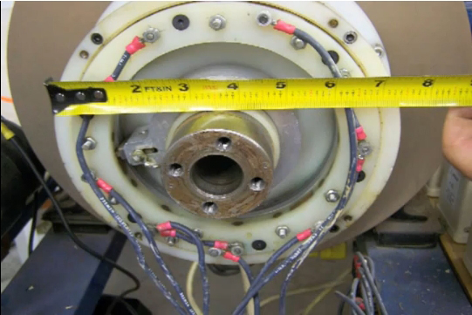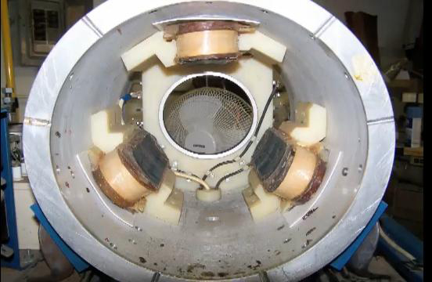
Excellent views of the commutator (left) and the stator electromagnets (right) Note the substantial thickness of the aluminum case. The commutator was re-wired for the 1980 retro-fit but other than that is still original. It is the electromagnets and the switching system that were really butchered beyond recognition.

There is other photographic evidence that suggests that the original electromagnets use in the E-Motors were actually custom auto transformers (3 or 4 wire devices) that boosted the 3KV – 5KV input voltage to the higher proposed 15KV potential. In the above-right photo of the stator of the E1 there is a white plastic plate in the back of the motor with a 4” aluminum slip ring mounted in the middle of it. Along the sides of this plate are a number of terminals (12 total). After the retro-fit not all of these terminals were needed and so they became unused. It is thought that originally this is where the 3 conductors of each stator electromagnet were landed.

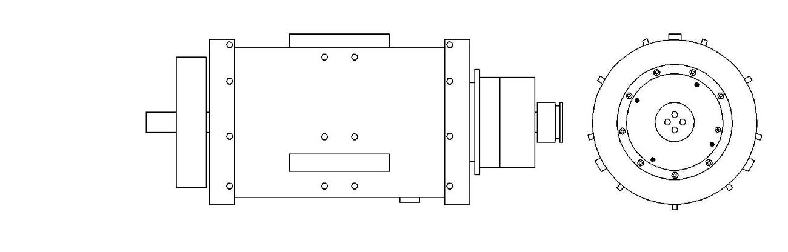
E2 – 3-Pole Motor “The Purple Motor” (circa 1963)

This motor is owned by Mr. John D. Riley who is accepting a minimum bid of $30,000. As of Jan. 2011 it has not been sold. Not much is presently known about the E2 aka “The Purple Motor”, however someone paid an extra fee to have both end plates anodized that fancy purple color. It is speculated that by this time (late 1963) potential investors were on site often enough that some money spent on “eye candy” was perceived as a worthwhile expenditure. It is assumed that this motor sports an aluminum case, but that has not been established until a clear side view becomes available.

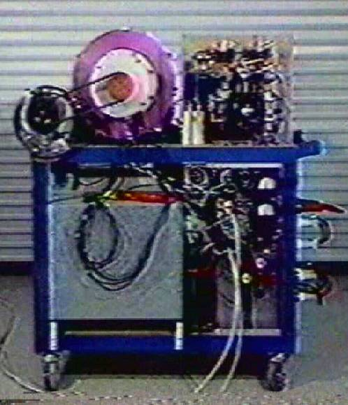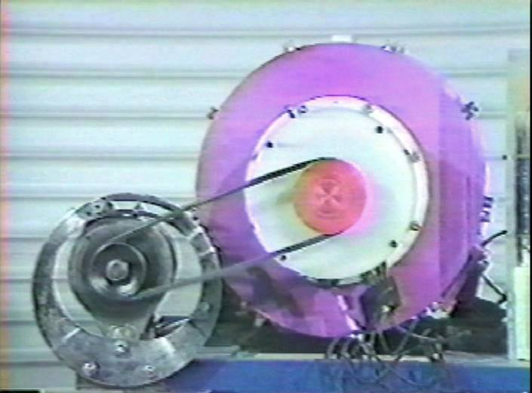
The E2 as seen in the 1986 Zetech promotion video Front end close up of the E2 (running). The white The cables are providing 30 KVA of 5 KV DC outboard DC generator/motor was originally used
from a large power supply cart (not shown). for starting, but no longer needed after the 1980
retro-fit program carried out by Nelson Schlaft.

Note the 12 Volt DC automotive generator attached to the E2 via fan belt – it is being used as a starter motor. All of the E-Motors were required to be brought up to a minimum speed (between 500 and 1000 rpm) before they could be operated as a motor. This was a real disadvantage of the technology, yet the presumed benefits were projected to overcome this irritation. It was probably hoped that a solution could be found to eliminate this ugly outboard device. One advantage of using a DC generator as a motor in this configuration is that it can again be used as a generator when the prime motor is up to speed. This allows a small variable load (up to 1 KW) to be applied to the main motor so that its efficiency can be easily measured with some degree of accuracy. It was probably this kind setup that allowed Mr. Cole to observe the over-unity process.

Until more information comes forth (hopefully in the near future) it is assumed that the “Purple Motor” is a near twin to the E1 aka the “Brown Motor” even though this is highly unlikely. The cost of these prototypes prohibits the construction of a twin motor just for the sake of having a 100% backup on hand. There must have been some important engineering difference between the two motors to justify their existence. Even though the motors were stamped with numbers this doesn’t prove that they were finished in that order. There were probably a number of development projects and experiments going on as engineering expertise was gained.

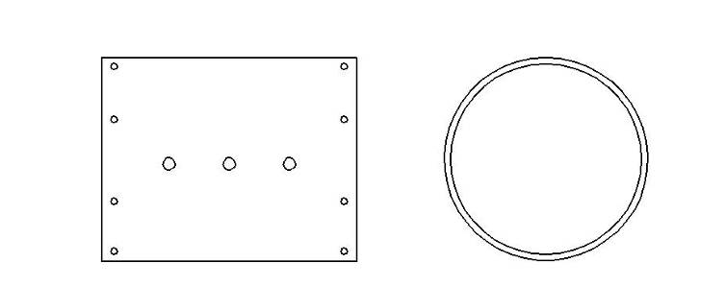
E3 – 3 Pole Motor Case (circa 1962)

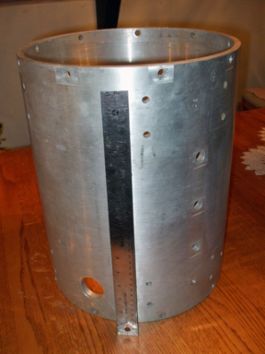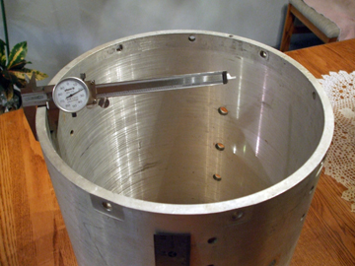
The E3 Motor Case in elevation Measuring the wall thickness of the E3 Motor case.

This is a fully machined 3-Pole Cole E-Motor case that matches the dimensions and hole patterns of the future E1 through E5 motors. The main difference is that its wall thickness is only 0.406” while photos of all the other motors in this series show a much thicker case (approximately 1” thick). It appears this particular case had been equipped at one time with electromagnets, since the bolt holes display wear marks that are caused when fasteners were tightened against the aluminum surface. This was not a cheap part to fabricate - especially in the early 60’s. It would have to been constructed in a shop that had some large industrial machining equipment to accommodate a part this big. The entire case has been turned and bored to specifications then drilled and reamed for 40 assorted holes. Most all of the holes were then re-milled to provide a flat mounting surface. The specific dimensions are: 12-5/8” OD, 12” ID, and 16” long. A quick estimate from the photograph from a local machine shop (2009) produced a quote of $1,750 plus $250 for the material (surplus) and a minimum four weeks lead time. Now this is using modern computer aided milling machines and a CNC lathe. The inflation adjusted cost of this part in 1962 would probably have been similar or more likely higher.

This motor case is fabricated from a section of large aluminum pipe. This is the most economical way to get the stock material; therefore Cole’s motor designs were constrained to few standard pipe dimensions. Typically the ID used in pipe specifications is held constant from model to model while the wall thickness changes according to grade and pressure ratings. Solid cylinders of aluminum are available for custom machining but the feed stock would then cost thousands of dollars rather than a few hundred. The ID for this case is 12” - along with the rest of the E Motors. The advantage is that as long as the ID of the motor design remained the same - the internal components could be switched from test bed to test bed very easily. For some reason this case was built and then abandoned in favor of a different case design.

It appears that the thin case of the E3 appears to have not met the demands found in this technology. There must have been some compelling reason for Cole to give up on this expensive part and replace it with another, even more expensive, part. It is an interesting question as to why a much thicker case was selected for the rest of E-motors. There are two speculative proposals; 1) the tolerance of the distance between the rotor and the stator was required to be very precise (on the order of 0.005”), therefore the thicker walls were needed to hold the shaft bearings very ridge. 2) In the later Free-Energy Engine models, the case is an active component in non-classical process, the mass of the aluminum is said to be an important parameter in the performance of this device. (However, this interaction has not been described in detail nor does it address the non-conductive cases)

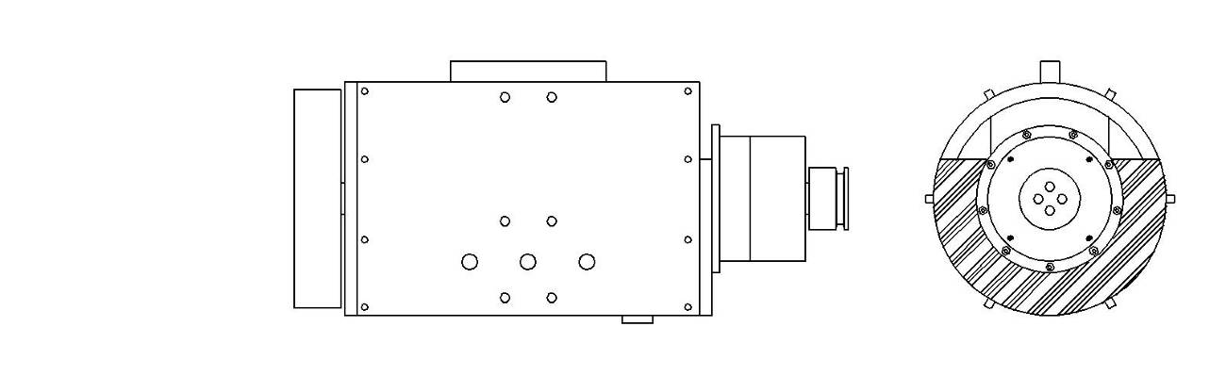
E4 – 1 Pole Motor “The Black Motor” (circa 1963)

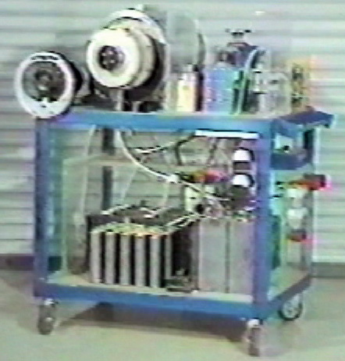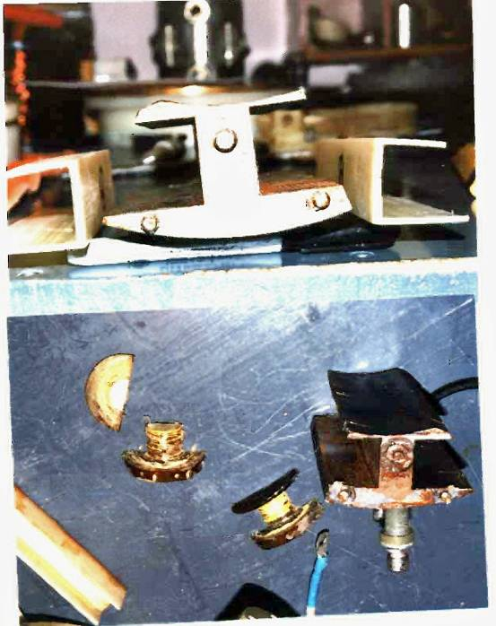
The E4 aka the “Black Motor” as shown in The E4 Electromagnets disassembled and photographed
the 1986 Zetech Promotion Video – The single by Al Francouer of B.C., Canada – 2004 showing the novel
Ignitron switch is a result of the 1980 retro-fit. cross section design. The half round insulators are for the
Video - Courtesy of Ken Hawkins electromagnet end pieces thus, suggesting a high voltage application.

The E4 and the E5 motors caused quite a stir in the Free-Energy community when they were recovered in 2000 from a shop in Dodge City, KS. As the story goes (from Ken Hawkins), Norm Wooten and Ken Hawkins were driving together along some highway in Texas while discussing their various opinions of past Free-Energy pioneers. Mr. Hawkins then mentioned his brief association with the Gray technology in the town of Dodge City. Apparently, a Mr. Russell Audrey had acquired a large part of the surviving equipment after Gray’s death, but was unable to make it work even after throwing lots of money at it. Apparently Mr. Wooten did a “U” turn on the road and immediately the pair headed towards Kansas. They got lucky and were able to find and purchase these two retro-fitted E-series motors, along with some other equipment.

Mr. Wooten disassembled both motors and studied what he could of this equipment. The next year he presented his findings to the 2001 Keeley Conference in Miami, FL. This was the first time that any of the Cole/Gray hardware had been seen or found. Many people thought that the E.V.Gray mystery was about to be to be solved. The presentation came and went, with a lot of program CD’s being sold, but no one seems to have been able to make sense of what Ken and Norm had discovered. These motors were not at all like the patent drawings for the “Capacitor Discharge Engine” that was granted to Gray in June 1975. The numbers on the case are confusing since the Black Motor was stamped with a “4” in several places, yet the engine that was promoted in 1973-1974 was called the EMA4.

It was a logical conclusion to consider the E4 to have been an earlier model since it only had one pair of internal electromagnets (A 1-Pole motor –or- one coil on the rotor and one coil on the stator). The E5 had all three sets of electromagnets installed so it was considered to be a later model (3-Pole). However, both cases and commentators were equipped to handle 3-Poles. For some reason it appears that Cole was working with complete 3-Pole motors and then stopped to restart with a single pole layout. Later on he again continued on with more 3-Pole designs. Apparently some technical issue came up (most likely the observation of OU) that required a backtracking of effort. If it had been desired to make a 1-Pole motor in the beginning it would have been a lot cheaper to machine it that way from the start. Each one of those machined holes adds cost to the final fabrication price. If they were not needed they wouldn’t have been there. Most likely a change in electromagnet design was being explored and a number of candidates were tested individually in the E4 housing. The successful electromagnet made its way to the 3-Pole E5 or one of the first prototype Free-Energy Engines. Unfortunately all of the original windings for the electromagnets had been removed and replaced with #14 AWG magnet wire during the 1980 retro-fit done by Nelson Schlaft. Mr. Schlaft reports that the original wire was of a much smaller gauge and that the electromagnets were coated in a brown waxy substance.

After a few years the interest in the recovered E4 and E5 died down and Norm decided to sell the motors since he saw no obvious Free-Energy technology in this machinery, which was probably an accurate assessment. The general community Internet interest in this technology had shifted to the missing power supplies. Norm sold the entire lot of recovered equipment to Alan Francoeur of B.C. Canada, who still owns these historic motors and is taking fine care of them.

The 2” shaft bearings used in the E4 are rated for 250 HP motor service and are still in production for $163.00 each (2005 prices).
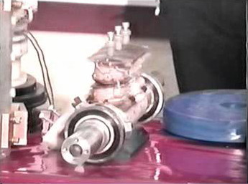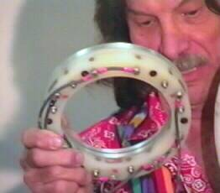
The E4 single electromagnet set (rotor and stator) as Norm Wooten displaying the control commentator
displayed at the 2001 Keely Conference. Presentation for the E4 (2001 Keely Conference).
By Norm Wooten
Al reports that when he received the E4 it appeared to have been stored with some kind of solvent since all the insulation and plastic parts were partially dissolved. The E5 motor appeared to be in good shape and was therefore put into storage as is. Al began a restoration effort on the E4. In doing so he generously shared his observations, on the Internet, thus he revealed some of the novel and unknown features found on this unusual machine. The most noticeable item was the odd cross-section design of the electromagnet laminated cores. The photo below shows an end view of the single stator electromagnet used in the E4. What is unique is the wide, but very thin top pole plate. A Finite Electromagnetic Magnetic Modeling (FEMM) program shows that this thin top section has almost no impact on the magnetic flux field that is developed around the core when current is provided. This geometry is far from a classical transformer core design. Al reports that the laminations were composed of what appeared to be typical high-silicon transformer sheet steel. These cores were probably made using an industrial punch process with a custom die. This approach probably resulted in a huge of waste of the feed stock material. The purpose of this creative design has not been well addressed by researchers in the field.

Another construction feature that Al pointed out, that was not touched upon in the Norm Wooten presentation, was the excessive insulation measures taken in this motors construction. The 2” solid steel shaft of the E4 is sleeved with a 0.200” thick Teflon tube that had to have been turned and bored to achieve such a tight fit. This sleeve was another one of those expensive parts. One can only assume what this insulation over kill for was for, but it definitely was necessary for the proper operation of the motor. The cores of the electromagnets on the stator were heavily insulated from the case. The cores of the rotor were also heavily insulated from the shaft by means of custom Nylon bushings. This implies that the case, shaft, and cores all had large potential differences between them during operation. This is very counter to classical motor design where all these components are generally held at the same potential (ground).

It is generally thought that the Cole/Gray motors operated with input voltages of 3KV to 5KV. The degree of insulation provided on the components of the E4 suggests that much higher internal voltages were employed (Up to 15 KV). It is unclear just how this increase in operating voltage was achieved or what purpose it was used for. Even large industrial motors (10,000 HP) rarely go above 5KV with 2.5KV being a far more common operating voltage. Something interesting was certainly going on in those early motors. Taken as a whole, as the motors progressed it appears that the internal voltage was being sequentially elevated with each model.

Al also provided a scaled drawing of the commentator of the E4 with its 15 contacts of two different sizes and two independent control slip rings. The purpose of all these control points is unknown and to date has not been decoded as to any sort of proposed function. Before the E4 and E5 motors were recovered, it was thought the fundamentals of the Cole technology were fundamentally simple. With the disclosure of the construction details of the commentator it became clear that this myth was indeed in error.

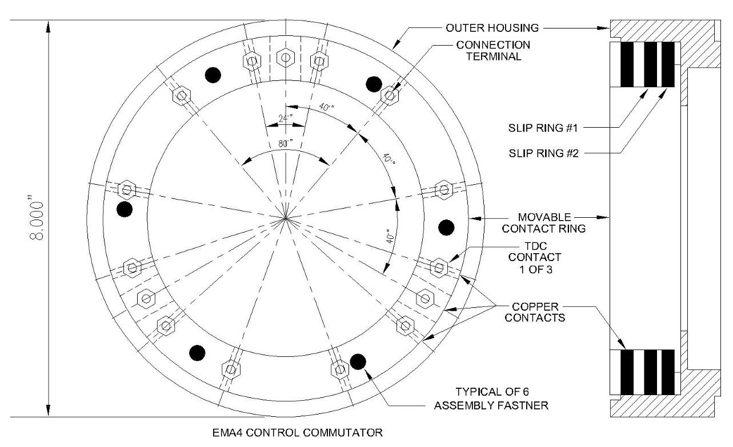

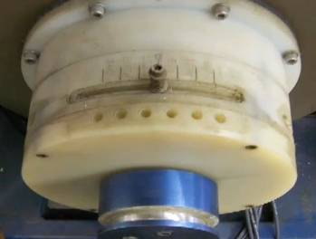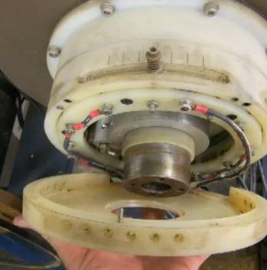

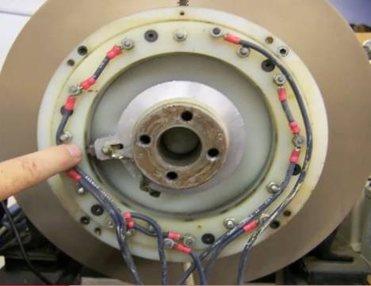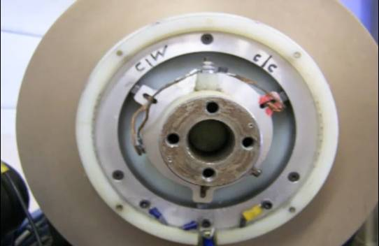

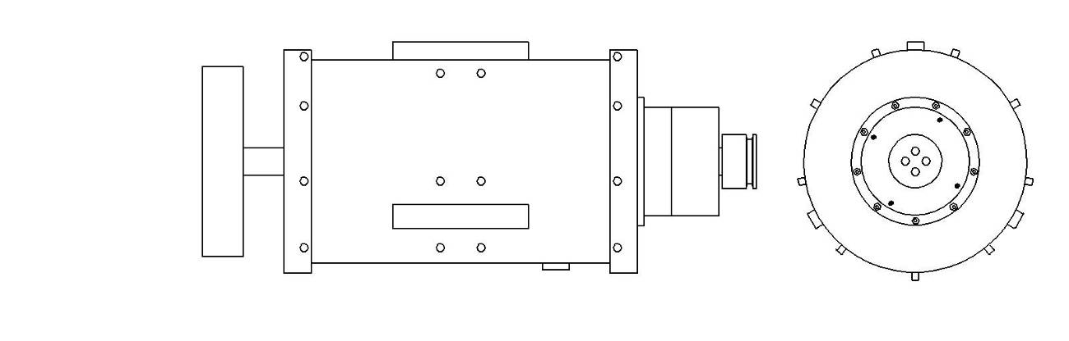
E5 – 3 Pole Motor (Plastic) “The White Motor” (circa 1963)

Not a lot of engineering exploration has been done on the E5 since Al Francoeur placed it in storage. Never the less this interesting model generates a lot of fundamental questions when the overall direction of this technology is analyzed. The obvious question is “Why a Plastic Motor?” It certainly isn’t for cost savings, as was the reason given to GD in his 1974 visit to Van Nuys (concerning the E5-A discussed below). The stock material for the parts that replace the aluminum and steel components in the E4 cost 4 to 10 times more. The shaft and end caps appear to be a material called Gatorite 10 (G-10) a fiber glass impregnated thermo-setting plastic that is common in electronic circuit boards. Mass produced G-10 thin sheets are relatively inexpensive, but G-10 that comes in larger dimensions is exceedingly costly. That 2” x 36” G-10 shaft would cost about $800 in today’s market, and that is before the cost of machining all the threaded holes. The case could be Nylon, but

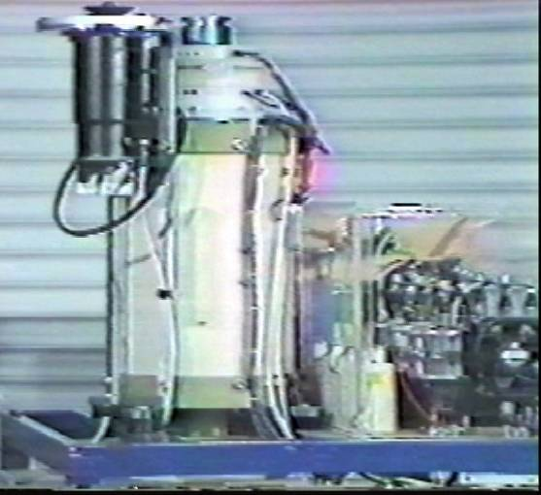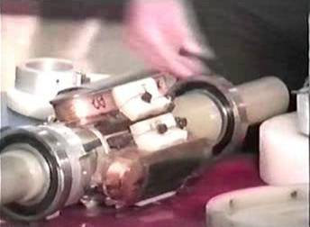
The E5 as shown in the 1986 Zetech Promotion The E5 Rotor displayed at the 2001 Keeley Conference
The purpose of the vertical orientation is unknown by Norm Wooten
Video – Courtesy of Ken Hawkins

Nylon does not machine easily for precession parts and absorbs a certain amount of water. A better choice would be Delrin. There are a lot of choices available today (and they are all expensive) but back in 1963 the selection of 12” plastic pipe that was dimensionally stable was limited. Various grades of PVC and ABS were available back then (used for water pipe) but it is highly unlikely these would have been selected due to their “softness”.

The main issue still remains. There was some important reason that Cole explored an all non-conductive construction. Since cost was obviously not an over riding concern then it had to have been some pressing electrical reason that was being addressed. It has already been propose that voltages around 15 KV were being utilized internally to the E4 motor due to its construction. If so, then it is reasonable to suspect that the all plastic motor design was an attempt to mitigate what ever problems that the 15KV was causing in a metal case/shaft/end end plate motor. Perhaps there was a desire to increase the power output by raising the internal voltage, which could only be done in a non-conductive enclosure.

Apparently, the engineering benefit of an all plastic motor enclosure was not worth the cost. This design approach was not employed in the later Free-Energy Engines. Perhaps the all non-conductive components caused a different set of problems. What ever the situation was this was the last prototype pulse motor. The later Free-Energy Engines for which we have photographs of show an internal construction with a substantial Teflon liner. It appears that the successful design approach ended up being a hybrid of materials. The Teflon liner provided the insulation properties while the outer aluminum case ensured dimensional rigidity.

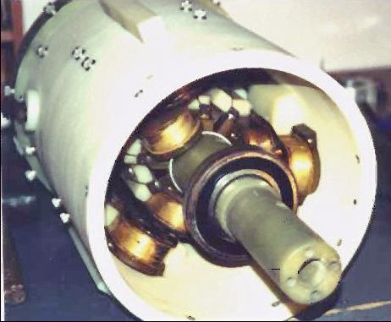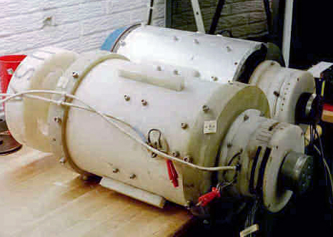
The E5 with the front end cap removed showing the The E5 and its sister the E4 as recovered in 2000 by
3-Pole rotor and stator. Photo by Al Francoeur Norm Wooten and Ken Hawkins in Dodge City, KS

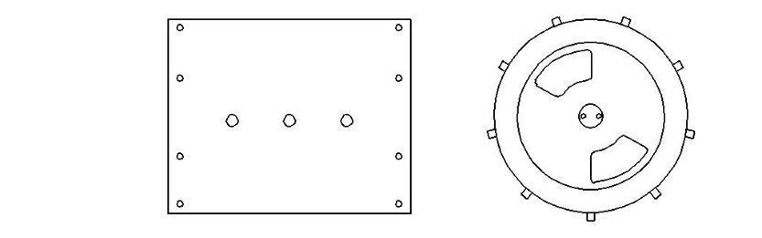
E5-A – 3-Pole Plastic Motor (circa 1964)

There is only one other known plastic motor like device in the present fund of information about the Cole/Hackenberger Motors. It is unclear if this unit was actually a functioning motor or some kind of test- alignment device. It has been given the label E5-A. Even though it was photographed by GD in June 1974 it is so similar in construction to the E5 that it is included with this commentary.

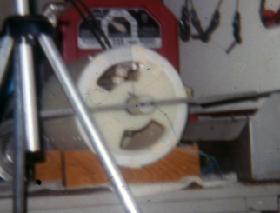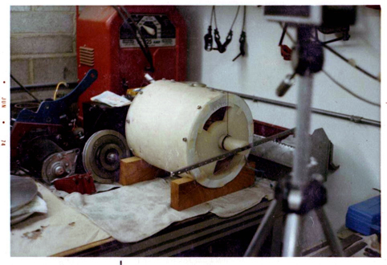
The E5-A as photographed in June 1974 by GD Side view of the E5-A

For a long time it was thought that this device was the E5. With higher resolution photos made available by GD it could be easily seen that such is not the “case”. The thickness of this motor’s plastic case approaches 1-1/2” and could well have been machined from a solid cylinder of material to achieve these dimensions. When these photos were taken the motor appears to be equipped as a One-Pole machine, much like the E4. Again, mounting holes are provided for the two additional sets of electromagnets, but they are not installed. It is unclear if the rotor is a three pole design or single pole. The design of this machine definatly belongs to the era of the Pulse Motors since the stator and rotor electromagnets are of a single coil design.

Notice the 36” bar handle that is attached on the end of the shaft. Also notice the heavy wire that is attached 90 º to the shaft as to make an indicator against the markings on the edge of the case. In this configuration the shaft can’t turn more than about 30º. There are no motor mounting brackets, flywheel, wires, commutator, or instrument wires on this machine. It seems to have been stripped of all its ancillary equipment. It is most likely serving as an AV demo device to illustrate the internal operation of the later Free-Energy Engines. It probably is a close relative to the E5 fabricated circa 1963 but is shorter (about 14” rather than a full 16”) and has internally mounted end plates rather than the external end plates as seen in the E5. This machine was probably a prototype for the E5. There is a good chance that the electromagnets used in this design are shorter than the ones used in the E5. When the E5 was made all the usable support equipment probably moved to the new motor leaving behind what we see here.

What is interesting in this motor design is the addition of open view ports that are not blocked with commutator components. This is the first motor to offer an unobstructed view of the internal arc process in real time. If this speculation is correct, then the E5A was an experimental transition apparatus to better understand the observed Free-Energy events. The principles learned with this machine probably provided the engineering criteria for the construction of the EMA1 Engine. This idea would also suggest that the first observation of an OU process took place with the operation of the E5 Pulse Motor.

About 30 days after these photos were taken this motor was confiscated by the LA DA and made its one way trip through the scrap metal shredder.

The fact that these two plastic motor designs existed begs the question as to what kind of technology would require such materials and just how was that technical problem at the time resolved?

Family Photo of the E series Motors

Here is a very fuzzy video frame of all the modified motors taken in 1986, less the “Blue Engine”. It looks like Gray had paid some rent on a secure storage facility remote from the Van Nuys shop to be able to keep this much equipment safe and dry for almost a decade. Fortunately he did this or all of this history that we are looking now would have been lost.

Researchers can gaze at this collection of expensive custom equipment and have no doubt that a lot of money and effort was invested in the dream that Marvin Cole pursued for a long time. Later E.V. Gray took this equipment to further his own personal dream of riches and adulation.
Any non-funded garage scientists who has ever taken a soldering gun to make a single Free-Energy circuit of their own would agree that the creations one makes is a poignant statement about their passion and craftsmanship. This photo displays an abundance of both qualities.

We may never know what the lost technology was that made these machines work but, the surviving prototypes still speak of a man with a focused intensity and burning desire to complete a formidable task. Consider the thousands of hours that were needed to design, draw, document, evaluate, model, and beg for more money. He continued on this way for years. He still worked as a chef until the day he left LA - so all this work was done on his own time. He didn’t have a staff of drafters, intern engineers, prototype technicians, consulting specialists, or even a secretary; heck he didn’t even have a computer to keep track of all this paperwork. It is reported by Gray’s 2ND oldest son Dr. James Gray, that upon E.V. Gray’s return to California, he established a group of “insiders” that funded and provided the technical support for his venture. It is unknown what kinds of financial or technical support Marvin Cole had.

All of these prototypes contributed to the age-changing breakthrough that Marvin discovered. Had circumstances turned out differently all of us would be driving cars powered by engines not much different than these shown.

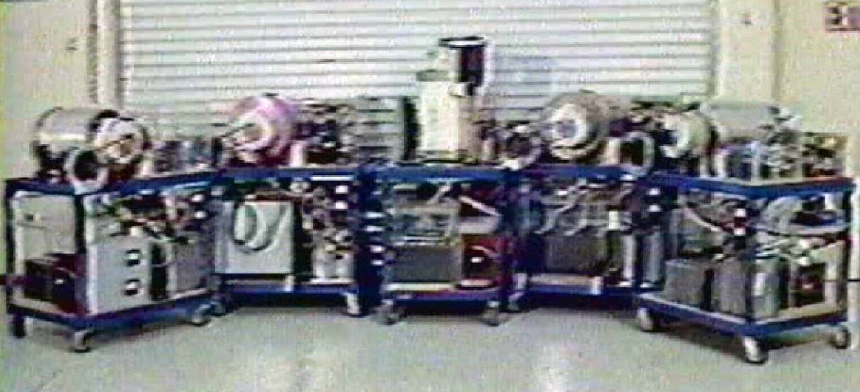
A Family photo of five of the 3-Pole E-Motors taken from the 1986 Zetech promotion video. These motors were all modified in 1980 to run on 5KV DC derived from 240 VAC 100 Amp mains. Despite the internal rewinding of the electromagnets and the addition of switching Ignitrons it is thought that the carts that these motors are mounted on are largely the same as they were when constructed circa 1961 to 1965. From left to right, the E4 -“Black Motor”, the E2 - “Purple Motor”, the E5 - “White Motor”, the E1 -“Brown Motor”, and the suspected E0 Motor (no color nick name).
Part II – The Free-Energy Engines

EMA0 – 9 Pole Model Mockup Engine (circa 1972)
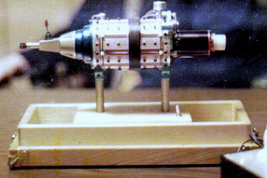

The EMA0, is a tiny (3” diameter) mockup model of the EMA4-E1 with a battery motor being used to make the inner rotor turn. This was used to make investor presentations. It was being used as early as 1973 but it is not known just when it was actually built. No doubt it was not cheap to produce. This model has recently been rediscovered (Dec. 2010).

Someone in the early 70’s commissioned a professional industrial model building shop to fabricate this miniature representation of the EMA4 Free-Energy Engine with an attached manual transmission. The finished product was a work of art and probably came with a large invoice. It is composed of almost all custom machined metal parts with five different colors of anodized aluminum. The case is a clear poly- carbonate cylinder that allows observation of the working internal rotor. The details observed in this mini-mockup are most interesting and deserve some serious technical review. There are construction features machined into this model that go way beyond what one would normally expect to see for investor presentations. Non-technical venture capitalists would not be able to appreciate the minute technical detail being displayed here. It would not have been wise for the inventor to disclose such important aspects, never the less that is what was done. This model sports a scaled reproduction of the internal rotor shaft that is powered by a battery operated DC motor concealed in the commutator section. Four “D” cell batteries are installed in the white mounting base. The EMA0 is held together with a multitude of tiny hex-head cap screws, jut like the full scale machine. The mockup transmission is machined brass. All of the modeled outboard equipment (DC start motor, Air blower, and Alternator) are equipped with small roller bearing pulleys. The fan belts are neoprene “O” rings that turn when the engine is operated. The company EMA logo is engraved on the front white plastic cowling.

The EMA0 exhibits several important construction details, two of which have not been observed from the surviving technical crumbs of this engine’s design.

1) The aluminum mounting pads for the stator electromagnets (made of magenta anodized aluminum) in the EMA0 are the full length of the engine case. It had been thought that these were separated in to two sections like the rotor electromagnets. This greatly impacts the various theories that speculate on the actual topology of the stator wiring.

2) The rotor shows three distinct circular copper buss bar rings in the center of the shaft. These have only been hinted at in the patent documents, but the model clearly shows their location and general layout.

3) The air flow piping is also clearly laid out. It appears that outside air was pumped into the front of the engine and then recovered from the rear to be piped to the rotor commutator section. From hear it probably flowed into the stator commutator section and was then exhausted.

4) There are nine conductors shown in the central “Floating Flux Field”. This is consistent with photographs of this same system element on the full scale engine, but helps verify the count.

5) The two small white terminal discs at the front of the engine are also presented in this miniature version. These are thought to be the control contacts that switch the engine from the electromagnet mode of operation to the electrostatic mode and back again.

The GD documents claim that Paul Lewis had this model on display in his office for some time to help potential customers get an idea of what the Free-Energy Engine looked like for his Fascination Car.

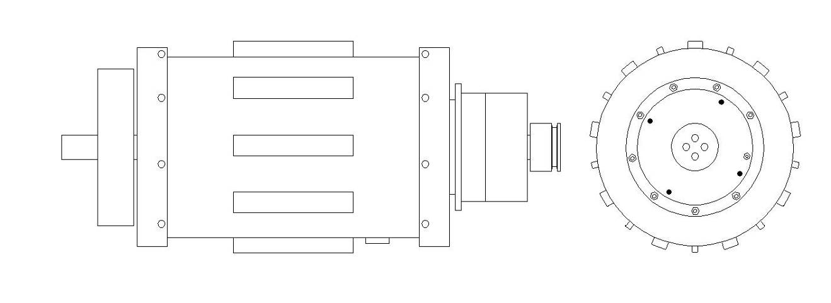
Conceptual Drawing of the EMA1

EMA1 – ? Pole Engine (circa 1969)

Again, almost nothing is known about the first true Free-Energy Engine. However it is assumed there was one - if the model numbering sequence started with EMA1. We can only speculate on how this Engine was configured and what it looked like. We are pretty safe in assuming that the first prototype in this series worked well enough to continue on, or else the whole effort would have reverted back to the Pulse-Motor project, which had some pretty good momentum of its own.

This author will make some calculated speculations about what this first engine might have looked like:

1) It was probably at least 12” in diameter since the later EMA4 was 16” in diameter and most of the motors before it were 12”.

2) It was a low power prototype on the order of 3-5 HP. Any output less than that would have been hard to measure a definite O-U process with out the aid of some sophisticated equipment.

3) It was probably a 3-Pole machine using “Major and Minor” electromagnets with 3 pair mounted in the front and another 3 pair in the back (to eliminate the slip rings). Thus a longer case was needed. The original over-unity effects were observed with a 3-pole machine and thus most likely this architecture was not deviated from at this juncture. More identical poles could be added later to increase the HP.

4) It used a more complex commutator than the E-Motor series, but not as complex as the later EMA4-E1 but still using 15+ contacts. This was needed to support the split electromagnet architecture.

5) It used unit power supplies along the same lines as those used in the E-Motors (mechanical chopper vibrators). This was most likely just like what is shown in patent #3-890-548 except they were single units and not the paired units described in the patent text. This was the only practical method to generate HV from batteries at that time.

6) While the unit power supply stayed generally the same the connections to the storage capacitor changed to take advantage of the electrostatic harvest pulse. This put a huge strain on the power transformers, thus Cole had to seek a custom fabricator that could build small transformers designed to handle high voltages on the secondary (up to 75 KV). Thus the connection with the Mallory Company of Carson City of Nevada came into being. They were manufactures of custom ignition coils. They had just moved to Nevada in 1969.

7) A backend battery was now required as part of the circuit operation. This was needed to capitalize on the electrostatic operation of the system and provide low voltage current carriers that could absorb and transfer energy from the electrostatic harvest pulse process.

The disposition of this engine is unknown. But it is highly likely that its internal parts were again cannibalized for the next prototype motor until just the case was left – like what happened to the E-3 Motor case.

Conceptual Drawing of the EMA2

EMA2 – ? Pole Engine (circa 1970)

At present there are no photos of the EMA2 Engine, however it has been proposed that this was the 10 HP model that was submitted to Crosby Research in May of 1973 for 10 days of evaluation. This is the only engine that has been technically reviewed by a 3rd party testing organization. The results were undeniably amazing. A Coefficient of Performance (COP) of 275 at a power level of 7.6 KW (10 HP) were reported. The entire test results have not been recovered so the actual duration and conditions of the trial runs have not been determined. It is reported that there were about 30 pages of documentation. It is known that the tests were conducted at leased facilities at Cal Tech.

This would be the motor to own for historical investment purposes. Its disposition has never been mentioned in the information available. It could have been cannibalized as well but we don’t know. It is very likely that it was still in the Van Nuys shop when it was raided in 1974 and thus ended its life via the scrap metal shredder.

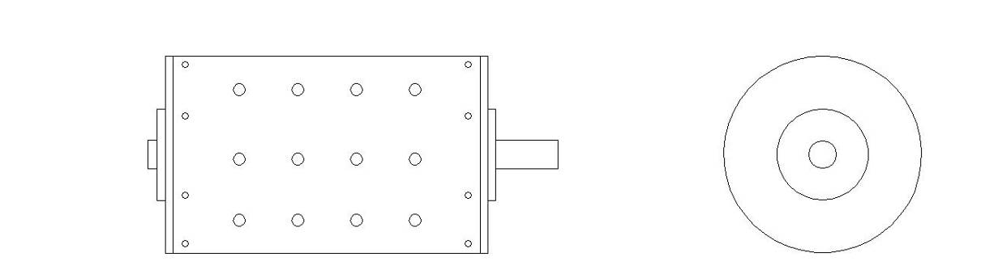
EMA3 – 9 Pole Engine Case

By now the proof of principle had already been well established and the next development quest was higher HP ratings. This was initially achieved by adding more electromagnets. These photos are the first hard evidence of a 9-Pole machine, from which all the remaining Free-Energy Engines will follow. It may or may not have been the first 9-Pole engine.

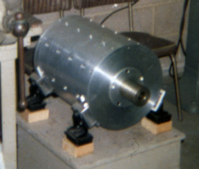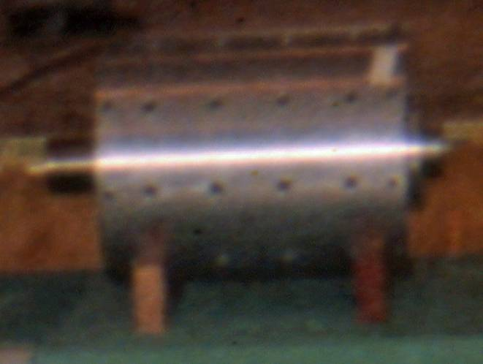
The EMA3 as photographed in Van Nuys in 1974. The EMA3 on display at the 1976 Stockholders meeting. by GD. Note that the electromagnets have been. The case engine mounts were cannibalized for the EMA5 removed and were probably installed on the EMA4 Fortunately this engine must have been in storage as not
engine. to have been confiscated by the LADA raid.

These photos clearly show that this early engine suffered from a terminal state of cannibalizism. The only thing left is the case and rotor shaft. Even the motor mounts were taken to be used on the EMA5. The EMA3 appears to be a 12” ID engine, just like the E-Motors, but clearly shows 9 stator poles front and back. The next engine will be the EMA4-E1 with a 16” ID case. Notice the evenly spaced holes for mounting the internal electromagnets in the above photos of the EMA3.

To consider what changed between the EMA3 and its replacement the EMA4 it is useful to examine the GD photo collection for a clear side view of the EMA4. In the photo to the left the stator electromagnet mounts bolts can be seen. It is thought that the electromagnets were moved to this case. The difference here is that the new case is larger -16” in diameter and about 25% longer. With the larger diameter it is assumed that there was more space available between the poles for larger Delrin electrostatic blocks. The distance between the front and back end was extended about 8” overall. There was more room allocated to the back of the motor and the space separating the front and back rings of stator electromagnets. All these changes required a new rotor to match the larger and longer case dimensions.

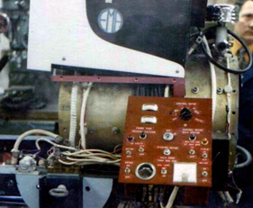
All of the ancillary equipment seen here, including the test stand, probably resided on the EMA3 at one time. Actual funding was becoming intermittent (despite many promises) thus, engine cases came and went, but the storage capacitors, electromagnets, and support sub-systems moved on to the next model. By examining the bolt positions in this side view photo of the EMA4-E1 (being converted to the EM4-E2) it can be seen that the space between the front and back sets of electromagnets has been significantly increased, right where the 18 each ½” diameter black Floating Flux Field (FFF) cables are wrapped around the center. In the EMA3 the stator electromagnets would have had about 1.5” of space separating their ends front to back. In the EMA4 engine this gap was increased to about 4”. It is speculated that this was done to inhibit arcs that would occasionally jumped between front and back stator electromagnets rather than jumping to the rotor electromagnets and then back to the stator. These variations of case design point to the novel process taking place inside the engine. It can be concluded that this technology needs to pay attention to relative position and dimensions of the internal components.

The disposition of the EMA3 engine case is unknown. Since it was not confiscated by the LA DA in 1974 (since it survived to be seen in 1976) it was probably taken during the FCC raid in 1979. The E3 motor case survived to modern times. This suggests that E.V.Gray managed to keep it in his storage collection. Had the EMA3 case been available he would have had it in1986 as well.

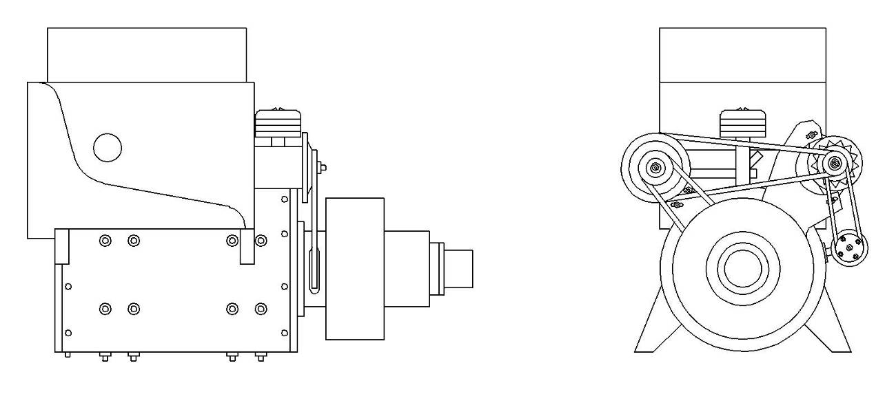
EMA4-E1 – 9 Pole Engine (1972)

Through out the entire E.V. Gray saga there are only a few crumbs of usable technical information that were ever disclosed. Of that, more is known about the EMA4-E1 engine than all the others put together. Any non-funded researcher, who bases their work on historical facts, will probably consider starting with what is known about this engine. This engine was the “preferred embodiment” of patent # 3-890-548 “Pulsed Capacitor Discharge Electric Engine” filed Nov. 2, 1973 and granted in June of 1975. This author contends that the text in the patent was intended to be misleading but the illustrations hold valuable clues. It is unknown just when construction was started on this machine, but it was ready for sale in Jan. 1973.

The two photos below were not taken at the same time (but close) since the one on the left has a manual transmission attached while the one on the right sports an automatic transmission. These attachments were never used in practice and are only shown to inspire dreams of profit for investors who considered investing in this venture as it might apply to the automotive industry. These photos were intended to be presented in the promotion literature that Gray distributed to his commissioned investment agents.

The photos were probably taken right after Pan American Enterprises pulled out of the project in the 1st quarter of 1973. Gray had to scramble to get replacement funding. He was set on keeping ownership of the technology thus selling stock would allow him some income without ever having to give up the secrets. However, he didn’t do the proper bookwork or advertise his corporation properly and therefore, paid dearly for this oversight later.

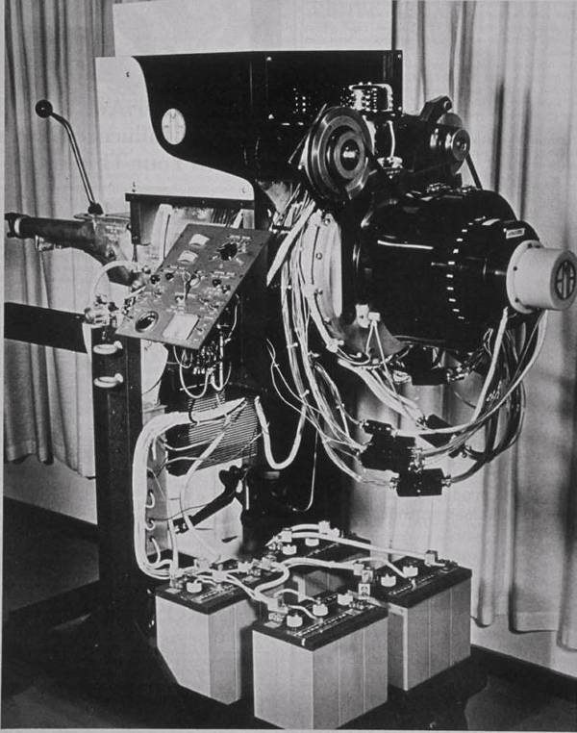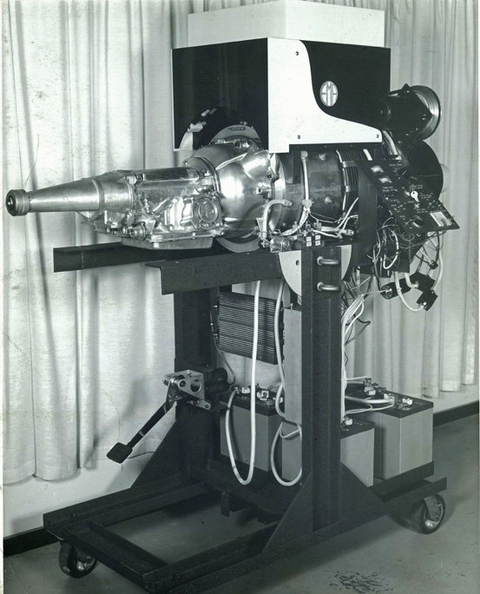
The EMA4-E1 front view showing the multitude of The EMA4-E1 back view. The hydraulic clutch is for the dangling control cables, the uncovered lead-acid manual transmission, while the oil cooler is for the
storage batteries, and the various outboard support automatic transmission or the hydraulic load pump that
devices (DC motor, Alternator, and a low pressure was used to measure output HP
high volume air blower)

This is the zenith of the Cole Free-Energy Engine technology. When these professional B&W photos were taken Mr. Cole had already left town. This is as far as he got with. It is still a master piece of complex hardware. He must have really been scared to leave a work of art like this behind. Never the less it was still a work in progress. There were a number of engineering issues that needed to be solved. There were two versions of this engine. The E1 model, shown above, is where Cole left the scene. Gray then hired Richard Hackenberger to carry on and make Gray rich. Hack’s first job was to increase the power output, thus the same engine was heavily modified from 1973 to 1974 to become the E2 version.

Unfortunately, for the next 6 years the technical advancement of this technology would be largely down hill. Mr. Hackenberger, an intelligent and motivated classical solid state electrical engineer, couldn’t understand the actual (and probably undocumented) process that was operating right in front of him. Gray was no help since he had even less of an understanding of what was going on. Never the less Richard spent the rest of his life in pursuit of resurrecting this technology. He knew it was an age-changing breakthrough that bordered on pure magic. He did everything he could to figure out what made the original machines tick, given the limited resources his boss E.V. Gray provided for R&D while spending the lions share of the investment capital on personal luxuries and lavish appearances. It seems that by 1979 Richard finally got something together with the construction of the EMA7 aka “The Blue Engine”. He then suddenly passed on in early 1980 from a week long flue like illness while hiding out in San Diego with Gray. Richards’s family didn’t even know where he was at the time of his death, and it took the authorities a month to find and notify them.

It is thought that the EMA4-E1 was a 32 HP machine. So far it appears to be the only Cole Free-Energy Engine that used a 16” ID case. According to Jack Scagnetti, in his 1973 article, the engine was 16” in diameter and 24” long. This machine worked well enough to entice the large Japanese mining and energy corporation, Pan American Enterprises, to sign a letter of intent with Gray in Jan of 1973 to provide a $12 million dollar research grant and a very lucrative Asian licensing agreement for some large non-disclosed amount. (This has been said to be in excess of $1 billion dollars). That deal fell apart when a large envoy of VP’s and engineers came to Van Nuys for one last series of verification tests. There was a serious equipment failure and Gray was unable to attempt repairs. The Japanese quickly came to the correct conclusion that Gray was not the originator of this technology nor did he really understand it. They took this opportunity to pull out of the deal, probably thinking that they could get the original technology cheaper from the real inventor or at least the same price with somebody who knew what was going on. It is unknown if they ever attempted to determine who the real inventor was or if they even tried to locate them. It is also said that the company couldn’t get financing for the research let alone the licensing agreement, so they were really looking for any excuse to save face and forget the whole deal.

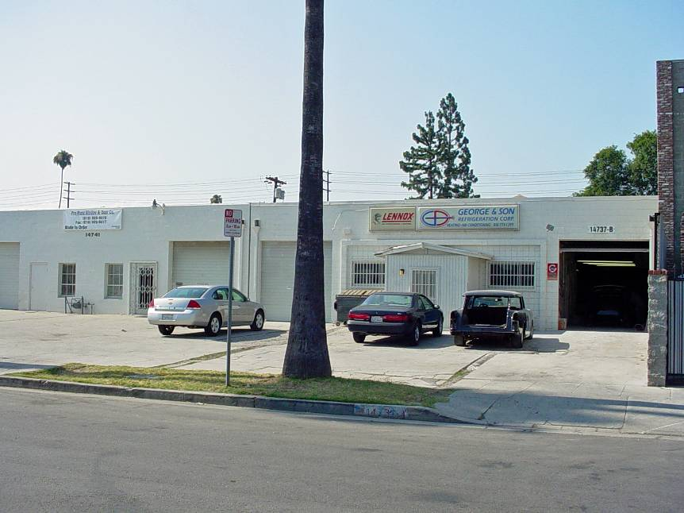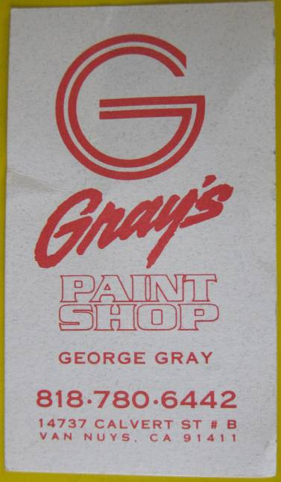

This is a photo of the former E.V. Gray shop on Calvert Street Van Nuys, CA taken in 2007. Mr. Gray’s nephew George Gray was still in business at the time in the right half of the building doing high end custom auto modifications. The vehicle parked in the open bay is a brand new reproduction 1932 Black “Duce Coupe” with all chrome engine accessories that was in its last stages of final assembly. Mr. George Gray is very reluctant to discuss anything about his uncle “Ed”. However he did show the author a collection of 30 each B&W photos from Jan. 1973 documenting the signing of the letter of intent with Pan American Enterprises. The EMA4 was being tested by a team of three Japanese representatives. Many of the photos were of a closed circuit TV aimed at the readout gauges on the output hydraulic load pump. Perhaps, even at this time, tests were done behind a protective wall should one of the storage batteries decided to explode (again).

John Bedini and his mentor Ron Cole (no relation to Marvin Cole) visited the Gray shop in Van Nuys about three times in 1973. During the first visit the EMA4-E1 was demonstrated – but not after that. It had a specific starting sequence. First the master key was turned on. John says he heard a low frequency buzz like that of a number of old automotive radio vibrators (100 Hz). Next a pushbutton was pressed and the engine was rotated by an outboard DC motor. The engine began to pick up speed for about 15 seconds. At a certain point (assumed to be 500 RPM) another switch was toggled on and the engine became alive. John reports that readings on the attached hydraulic load pump indicated an output of 87 HP. It is not clear just when John and Ron visited Mr. Gray and therefore it is unknown just what conversions had been applied to the E1. For the sake of this discussion we will assume that the major E2 modifications had not been made. The engine was operated for a period of about 15 minutes before being shutdown. If the HP readings were accurate to within 5% then some simple math will disclose some interesting observations. The four fully charged golf cart batteries at most could hold 21.6 million Joules (250 A-hr at 24 VDC for 15 min.). The engine produced 59.5 million Joules in its 15 minutes of operation (87 HP x .76 KW/HP x 15 min.) This is COP of 2.75 assuming all of the energy in the batteries was consumed. The actual COP was probably much better since only a fraction of the energy in the batteries was claimed to be consumed. If only 10% of the stored energy was used the COP jumps up to 28.3.

The EMA4-E1 was not a self runner. No matter what they did the engine eventually ran the batteries down. The length of time it took to do this has not been disclosed. It certainly wasn’t for lack of available energy, since there was plenty; it was because the lead-acid batteries couldn’t hang onto it. Today there are several other possible cost effective engineering solutions that could be used to address this problem.

Dowd Cannady, another first hand observer from 1973, reported that when the engine was operated for him it made a loud and distinctive roar. He also reported that the engine case became electrified - not unlike the charged sphere of a Van d’ Gaffe electrostatic generator. Yet, in June of 1973 Jack Scagnetti reported that the engine ran quite. It is unknown why different observers in the same year have such diverging accounts as to how the engine ran (unless Gray was running the engine just with the DC motor and never actually engaged the engine). Perhaps different modifications were in place at different times that changed the reported performance parameters. John Bedini didn’t mention what kind of sound the engine made when it was operated for him. (I need to ask him about this – after things settle down from the presentation of the “Windmill”)
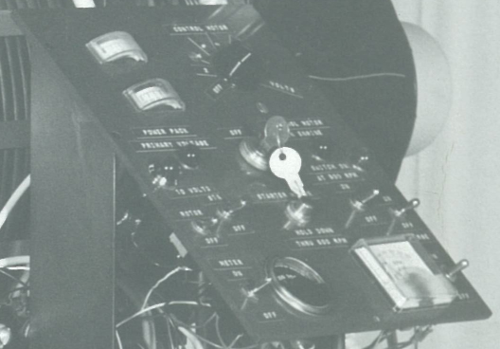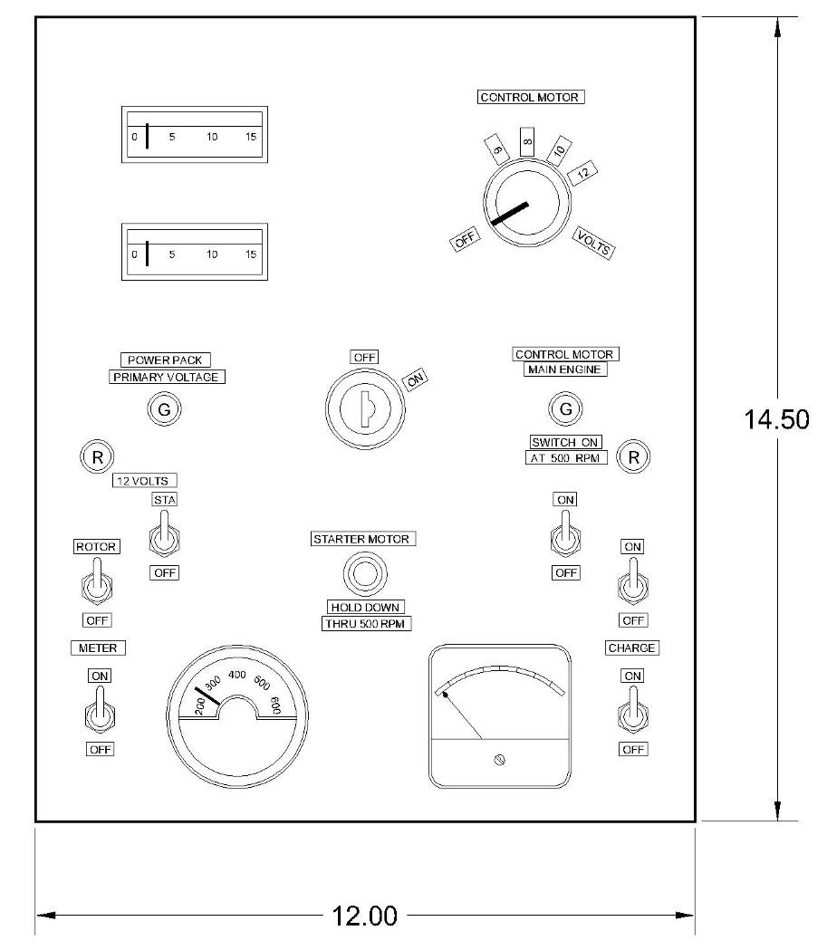

This is a high resolution scan of a poster sized photo of the EMA4-E1 (20” x 12”). There is enough captured detail here to determine the writing on the labels of the control panel. From the GD collection

This is the only engine that has any surviving published operational statistics. These come from the 1973 Jack Scagnetti Article.

Input Power: 12 volts dc (of a 24 volt dc system)
RPM: 2550 RPM constant
Torque: 66 lbs / constant
Horsepower 100 HP
Brake Horsepower: 32.05 HP
Foot-pounds / minute 1,057,650
Foot-pounds / second 755 lbs / includes 110 lbs for four 6-volt batteries
Volume: 42” long x 18” wide x 22” high
Engine cylinder is 16” x 24”
Speed-Switchable 500 – 1300 – 1950 – 2550 – 3350 – 4100 RPM
Magnetic Field 360º all directions during engine operation
Orientation

It is unclear just how this data was obtained or what kinds of instruments were used to establish these measurements. It is also unknown if this was a test that Mr. Scagnetti observed first hand or was extracted from data derived some previous test report?

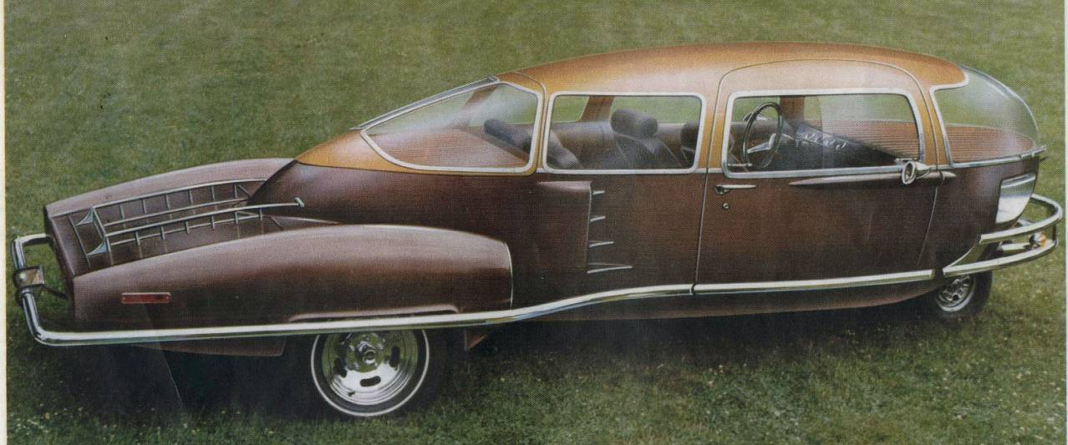

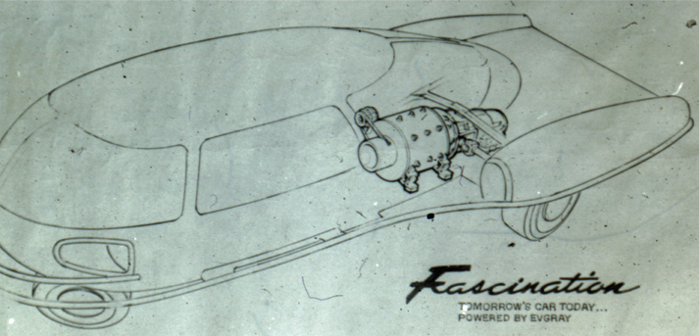

This is the Fascination prototype 3-wheel card invented by Mr. Paul Lewis of Nebraska. The lower photo is a conceptual drawing of how an EMA4 type Free-Energy Engine would be installed in this vehicle. It never happened, not even close. The EMA4 engine didn’t have the dynamic response necessary to operate an automobile. The real problem was a lack of funding to build additional EMA4 type engines. After the Japanese pulled out in 1973 Gray was left with out a funding source. Apparently Mr. Lewis had lots of dreams and good ideas but not enough money to completely take over production of these engines. It is odd that a man with outstanding mechanical skills and some knowledge of manufacturing couldn’t assess the actual state of development the EMA4 was in and avoid advertising to his customers something that Gray couldn’t deliver. It is said that Gray and Lewis parted on not so pleasant terms. Lewis apparently had invested what resources he had in gearing up for the first batch of 100 engines that Gray was suppose to deliver in the first quarter of 1974. When theses engines didn’t arrive things went bad for Mr. Lewis and his company folded a year later.

There is a document in the GD collection, written by Richard Hackenberger, where he explains why there are two horsepower ratings listed. Electric motors and automobile engines use different standards in determining their power output ratings. Electric motors are designed, tested, and rated for constant steady loads. The main limitation is heat build up. Automobile gasoline engines are rated near their short term peak power output, disregarding the impact of longer term heat build up. For a gasoline engine the continuous power output is far less than its peak power. It really depends upon how large of cooling system is attached. For the EMA4 engines the intent was to compete with gasoline engines in the automobile market, therefore the designated horsepower rating had to be similar as to how automotive engines were rated. Richard seems to have merely multiplied the constant power output of the engine by three to get the 100 HP rating. In reality the EMA4 engines didn’t do very well with sudden increases in power output. They could operate at a higher speed, but the transition was slow and gradual. They also had a tendency to stall if a load was applied suddenly. The EMA4 engine didn’t take much fuel, but the common gasoline engine could run circles around it as far as dynamic performance was concerned. This issue never became a problem since the engine never made it into a street vehicle. Mr. Gray’s technically uninformed promotion of his Free-Energy engine to Mr. Paul Lewis as just the thing he needed for the power plant in his new experimental Fascination Car was indeed very short sighted. Despite its outstanding Free-Energy properties the EMA4 could never operate a vehicle in the state of development it was in.

The description of the Magnetic Field Orientation in the Scagnetti article is interesting. It is the author’s contention that this was not a magnetic field being described but a high potential electrostatic field, as observed by Dowd Cannady.

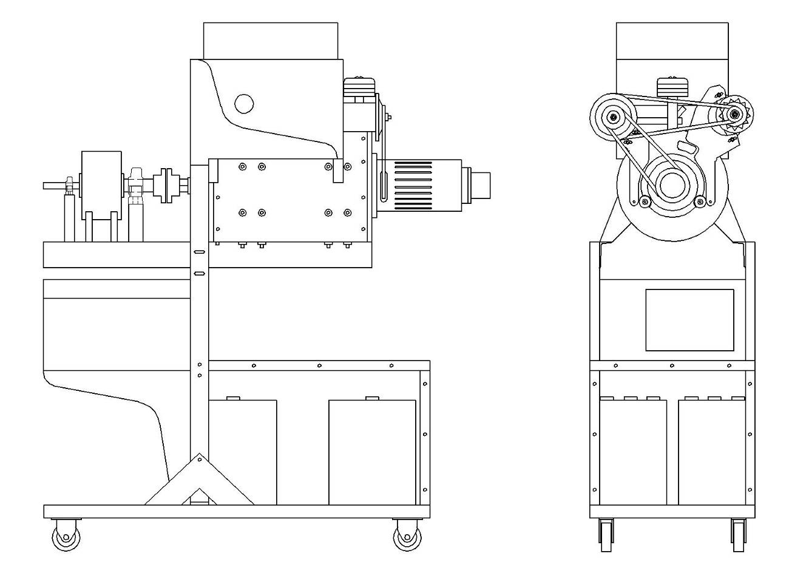
This drawing is done in full elevation to show the relative size of the added power supply pack added to the back of the test stand.

EMA4-E2 – 9 Pole Engine Modified – April 1974

Several changes and modifications were done to the EMA4-E1 to make it the EMA4-E2. The major changes were a new and larger power supply system plus a redesigned rotor. The engine case and the stator electromagnets appear to have remained the same. Some view ports were added and a reconfiguration in the outboard support devices was made. The DC start motor and alternator were combined into a single DC generator/motor and the air blower was upgraded. It is unknown how well this redesign worked out. It is reported that the engine was not demonstrated very often, if at all, during the first half of 1974. In July of 1974 the entire collection of shop prototypes were confiscated by the LA DA for alleged stock fraud. The remains of the shredded equipment were not returned until June of 1976.

Three observers have reported that the modified EMA4 developed a real bad habit of causing the backend lead-acid batteries to explode. Thus a thick clear Plexiglas enclosure was added to at least keep battery fragments off the walls of the shop. Finding a battery that could withstand the huge electrostatic harvest pulses consumed a lot of company time and testing. From an engineering stand point the question always comes up “Why wasn’t the battery eliminated from the system? After all at a COP of 275 a small fraction of the output could be used to recharge the batteries from an ancillary alternator.” This is a good thought, the problem was that the lead-acid batteries (1/2 of the battery bank) were a vital circuit component to the non-classical operation – therefore they couldn’t be eliminated that easily. The solution that Mr. Hackenberger selected was to add a large series capacitor in line with the connections that supplied the harvest pulse. This idea saved the batteries, but it appears that it also hobbled the Free Energy production. It is reported that Gray and Hackenberger would argue late into the evening about this modification. Apparently Mr. Hackenberger prevailed since this same feature was used on the EMA6 engine and is later shown in the 1986 patent #4,595,975 “Efficient Power Supply Suitable for Inductive Loads” as component #38.

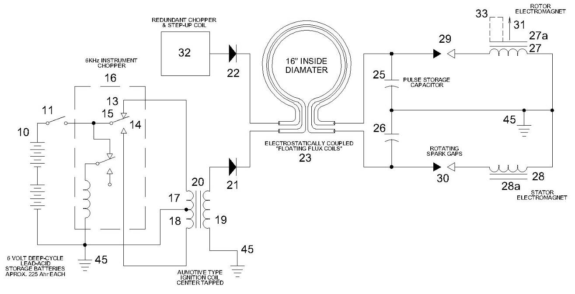

This is a modified schematic showing the unit power supply that was disclosed in patent #3-890-548 for the EMA4 engine. It has been largely determined that the conductors of the “Floating Flux Field” made one loop around the motor case (most likely composed of high voltage RG-11 Coax cable). This drawing has given researchers heart-burn for years, as well is should since it only presents about 30% of the circuitry actually employed and what is shown contains errors. The load connections to the electromagnets are grossly misleading. The most common circuit issue is the question about why the chopper power supply is using half-wave rectification rather that the much more efficient full-wave rectification. To date no one has proffered a good technical explanation for these connections (if there is one). The best idea so far is that the Gray just sketched some erroneous connections together, since he had very little understanding of electronics, and then had his drafter draw these illustrations for the patent application.

During the E2 upgrade program the mechanical chopper power supplies disclosed in patent #3-890-548 were replaced with larger capacity solid state devices (most likely full wave). The number of power supplies was also increased by a factor of two (or slightly less). All these power supplies required some large heat sinks with cooling fans, thus, a larger enclosure was needed. It is rumored that once these changes were made things didn’t work out so well. The transistors were regularly being destroyed from the transient voltage spikes induce during the harvest pulse cycle. It is assumed that this is why the EMA4-E2 spent much of its time in a “non-operational” status during most of 1974. Corrective measures were probably underway at the time of the LA DA raid took place but were obviously never completed. It appears that not a whole lot of load testing was able to be accomplished with this engine due to it high failure rate and the limited time between its initial commissioning and the confiscation. As a result we know nothing about how successful Mr. Hackenberger was with the upgrades.

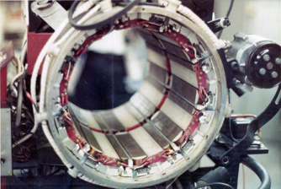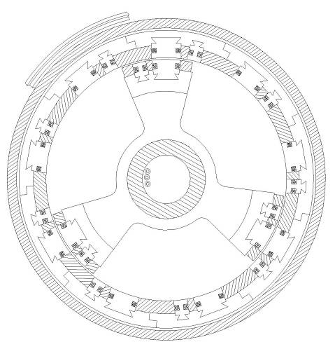

April 1974. An important photo of the EMA4 stator assembly during its retro-fit showing construction details of the “Major” and “Minor” electromagnets. From the GD collection. The drawing on the right is an illustration copied from patent #3-890-548. Notice how closely the layout of the stator electromagnets match the “preferred embodiment” of the patent drawing. It has been said that during this time Mr. Paul Lewis was making the rotor upgrades in his shop in Sidney, Nebraska. This photo provides a number of key insights into as to how this engine was actually built. It gives a much better idea as to what kinds of constructions materials were being used that were previously only hinted at in the patent drawing cross section.

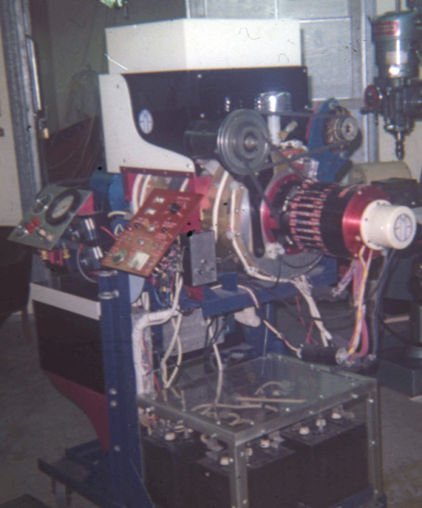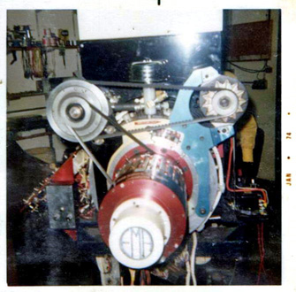
Photo of the completed EMA4-E2 in June Front view of the EMA4-E2, just a few weeks before its
1974. Notice the added black box on the confiscation. Note the small square view window that has been
back of the engine stand. GD collection machined into the front of the engine. This was installed so that
Mr. Hackenberger could observe the arcs between the stator
and rotor.

When these photos are compared to the B&W photos of the EMA4-E1 it is often assumed that the front end of the engine had been greatly modified since the observed dimensions are different. In reality it’s the same equipment but two large front end cowlings on the E1 variation had to be removed for the E2 re-design, thus making the commutator section look vastly different.
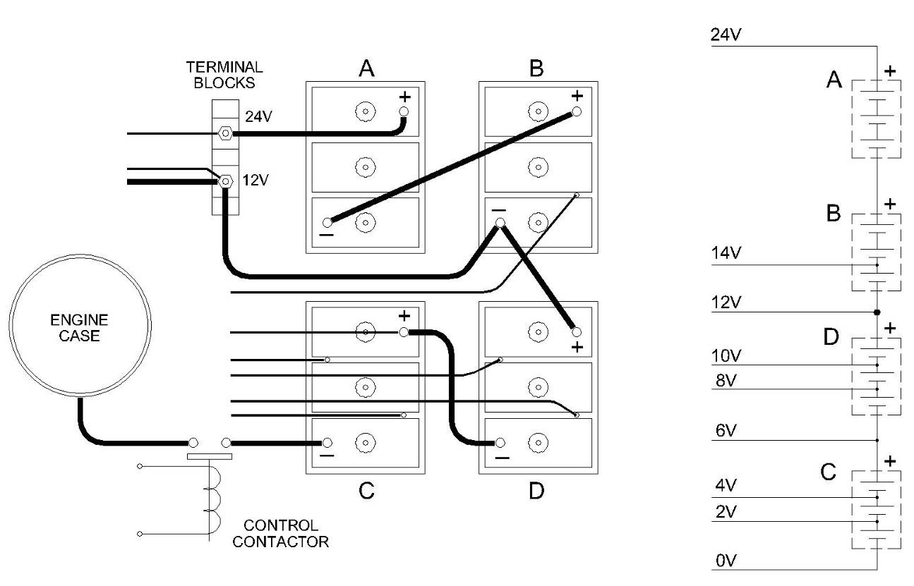

This drawing shows the novel battery connections used on the EMA4-E1 and EMA4-E2, as disclosed from the Valentine and GD photo collections. There were two battery banks. It is thought that the various voltage taps are used for speed control, but how this is actually achieved has not been established. Notice that the case of the engine is at the lowest potential relative to the lead-acid batteries. The heavy 12 volt tap is intended to operate the 12 volt starting motor. It is speculated that the 24 volt tap is used to provide power to the DC to DC chopper converters that supply the pulse capacitors. The lower cells of the battery bank are speculated to be used in the non-classical electrostatic generation cycle. The heavy duty 6 Volt golf cart batteries (250 A-hr) have been modified by drilling into the encapsulated bus bars and adding inter-cell connections, thus providing 2 Volt taps points. The voltage tap selected determines how many low energy charge carriers will be initially provided to the electrostatic process, thus controlling the final output.

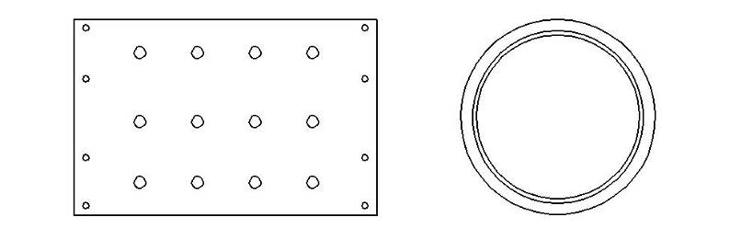
EMA5 – 9 Pole Engine Case (1974)

In the 1973 Jack Scagnetti article, he mentions how the size of the engine could be condensed to a 9” x 12” cylinder. Well, the replacement model for the EMA4-E2 didn’t quite make that much of a size reduction, but it did shrink down to a 12” x 18” diameter case with less space between the front and back electromagnets.

This engine never made it past what is shown in the photos below. According to GD this case was confiscated by the LA DA in July 1974. The agents who were loading up the equipment for evidence dropped this case on the shop cement floor. When it was returned it was examined and found to be so far out of round that it was un-usable for any further construction. This “public” explanation has been questioned by the author. If all of the other confiscated equipment was passed through a scrap metal shredded, then why didn’t this component receive the same fate? What ever the reason it appears that the EMA5 case was never populated with electromagnets or seen again.

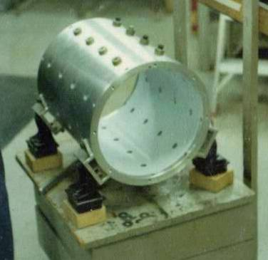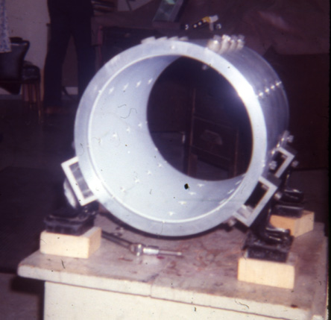

The Case of the EMA5 from a GD photo taken in June 1974. This component had just arrived from the fabricators (probably about $2,500 worth of machining with the liner). Note the Teflon case liner – it appears to be about 0.250” thick. The engine mounts are assumed to have been cannibalized from the EMA3.

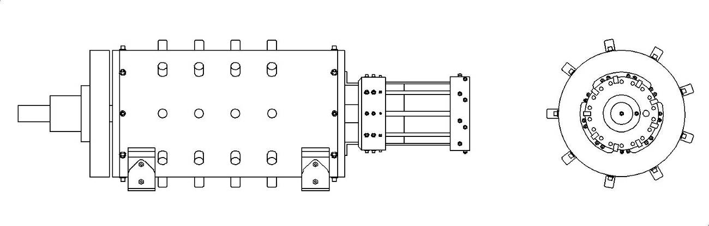

EMA6-E1 – 9 Pole Engine (Jan 1976)

After the LA DA raid in July of 1974 E.V. Gray and his associates were left with no operational prototypes. Even the case for the next generation EMA5 had been taken, along with any other fabricated parts that had been delivered and were on hand in the shop area. The resulting legal litigation essentially stalled any ongoing international marketing projects. Mr. Gray had already licensed the technology domestically to a Colorado company called Electrotech. He had received a $500,000 down payment so he had some reserves, but he also had at least 5 full time staff plus himself to pay. The decision was made to fabricate another prototype engine as quickly as possible to assist in the upcoming court battle with the LA DA. If Gray could demonstrate a working Free-Energy engine in court then the case would be dropped and he would have additional documentation to assist in his marking plans. According to GD all other ongoing development projects were immediately dropped, such as the Electrostatic Generator.

Mr. Hackenberger was given his marching orders to produce a new engine as soon as possible. It is unknown if the shortage of time and/or money resulted in the design of the EMA6-E1, or if this was his pet design all along. The EMA6-E1 has a different form factor than the EMA5 case; it is about 25% longer. So, there must have been something important that “Hack” wanted to stuff into that extra case length. There is a good chance that the EMA5 case had already been designed by Marvin Cole before his departure. Therefore, Richard took this opportunity to lengthen the case to make his version of a Free-Energy Engine.

It is easy to notice that there are no outboard devices on the EMA6 like what cluttered up the EMA4 (i.e. DC start motor, Generator, and Blower). Perhaps this is what is hidden in that front end 10” of extra motor case.

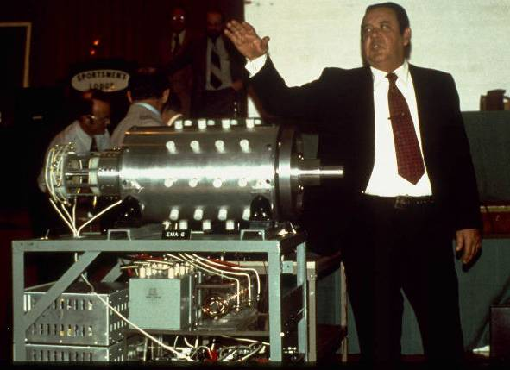

This is the ubiquitous photo taken by Tom Valentine in Jan. 1976. This image circulates around the Internet when discussing E.V.Gray and his Pulse Engines. This was the height of Gray’s business presentations. Despite all the glitz and show that dressed up this meeting Gray was in serious financial trouble. In addition what he is displaying was a real step backwards for the technology. This engine never did perform anywhere close to the achievements of the EMA4 engine. Many researchers have focused on the novel components just under the engine case – the concentric copper rings later called the “Converter Element Switching Tube” (CEST), believing that this custom device was the source of the non-classical energy gain. This circuit element was later patented in 1986. At the time it had no patent protection and was displayed to the public (with cameras) in a clear Plexiglas enclosure. If this component was really the heart and soul of the Free-energy production do you think the three board member lawyers sitting at the head table (on stage) would allow this kind of public technical disclosure?

The basic architecture of the EMA6 was in progress and was bread boarded when John Bedini and Ron Cole visited in 1973. It is uncertain if this was a leftover concept from Marvin Cole or was an original approach conceived by Mr. Hackenberger. This setup is documented in the John Bedini Field Notes. It appears that Richard was undertaking a number of major changes from the Cole design. This is very risky business when working with a new technology, especially one that does not yet have an established and tested theoretical model to base further engineering judgments upon. Richard was most likely very well aware of this fact, but time, money, and circumstances didn’t allow for a duplication of the proven EMA4 design. All of his power enhancements, size reduction, and simplification ideas had yet to be tested. He was probably forced to go for broke and come up with a design that was his best compromise between functionality, cost, and the time constraints.

There was about 17 months between the LA DA raid and the presentation of the EMA6-E1 at the Sportsman’s Lodge in Jan 1976. This was an important event for Gray. Electrotech, the company that had bought the domestic licensing rights, was now suing him for breach of contract. This is a common business maneuver used to extract patents rights from inventors who don’t have the ability to carry out extended litigation. Or, it could have been that the Pulse Engine patent granted in 1975 didn’t disclose enough information to reproduce a Free-Energy Engine (actually it hardly discloses anything useful at all). What ever the actual legal facts were Gray was running out of money, or already had. This was a last ditch effort to inspire previous investors to again invest in the new wave technology. He certainly went to great lengths to put on a good show.

The problem was that the just off the bench EMA6 failed to perform. When Dr. Chalfin (a board member) was asked what the horse power output of this new engine was; he truthfully replied “2 HP”. Everyone at the meeting knew that the previous model was touted to have operated at 100 HP, so why was this new model rolled out with fanfare and stage lights to demonstrate only a tiny fraction of the capacity of its predecessor?

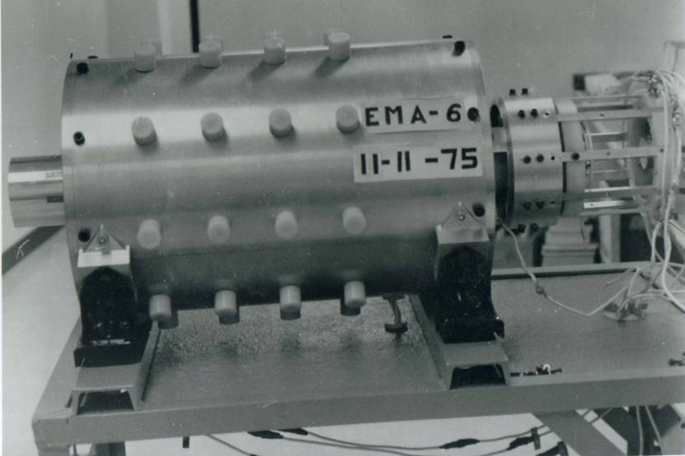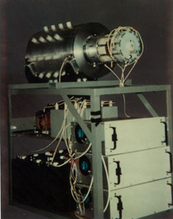
The EMA6-E1 under construction in Nov. 11, 1975. “Hack” has The EMA6-E1 at the Sportsman’s Lodge event.
about 8 more weeks to finish off this demo model before its début This view shows details of the three unit power
at the Sportsman Lodge on Jan. 9, 1976. It looks like he has a way supplies, including their cooling fans.
to go, not including commissioning, testing, tuning, adjustments, Additional features of the control commutator
and documentation. are also seen.

The general verdict of those in attendance was quite predictable and not in favor of Gray’s hopes. He didn’t receive a dime from the media presentation or the stock holders meeting. Both events were unmitigated financial flops. This is a classic example of what happens when there is a conflict of interests between the engineering department (Hackenberger) and the marketing department (Gray) – but we don’t know the whole story of these trying times.

From here the financial walls came collapsing down all around them. This was the last stockholders meeting ever. Most of the board members soon resigned so as not to be involved in the ongoing litigation with the Electrotech Corporation. The landlord booted Gray out of his lavish office facilities at the LA airport after being 3 months behind in the rent. The phone was disconnected. His limo was repossessed by the leasing agency while various collection agency associates were calling anybody who might knew where Gray was. Worst of all, his 2nd wife Renate and her father Fred Lentz joined the opposition to collect damages from Gray (after draining what was left in the company bank account). Mr. Lenz came to believe that he also had a valid claim against the ownership of the EMA6 after some lawyer told him so. He had machined major portions of the engine, and probably didn’t get paid for his labor. These accounts are from GD.

There were probably some court room sessions and Electrotech finally got complete domestic control over the Pulse Motor Patent, but there was nothing else they could get that had any financial value. Gray hid the EMA6 engine prototype so that he and Hack could continue to work on it. When it was obvious to the various lawyers that Gray was completely broke they gave up on the different lawsuits. Renate and Fred probably got nothing. Electrotech, or rather the oil company behind the shell corporation, got what they wanted all along and that was a termination of development of the Free-energy technology. They had the judgment of ownership for the patent (plus other damages) and could immediately tie up Gray or any future investors in court should he attempt to do business in this field again –at least in America.

Hack got a job as a taxi cab driver to pay his rent. Gray leaned on some of his relatives for support for the next couple of years, but he still fully intended to make a big comeback.

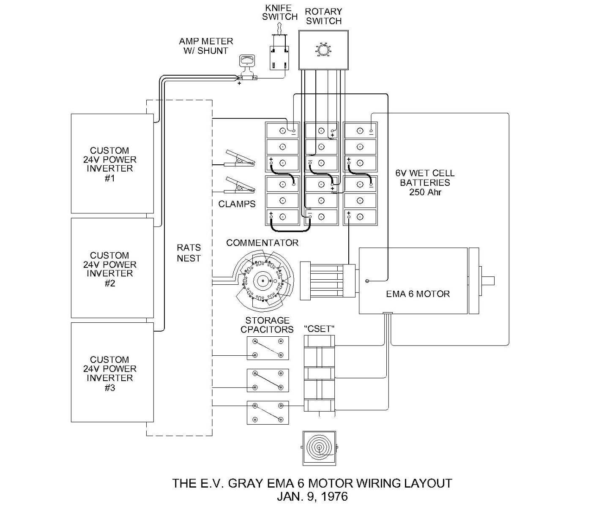
The wiring layout for the EMA6-E1 as it was displayed at the Stockholders Meeting Jan. 9, 1976. From the GD and Valentine photo collection’s. This is Mr. Hackenberger’s redesign of the Cole system. It is thought that the original electromagnets on the rotor have been replaced with permanent magnets, thus reducing the complexity of the commutator. The enigmatic “CSET” device is thought to be some kind of high voltage arc switch to control pulses to the stator electromagnets. Three large transistor power supplies are used to replace the multitude of smaller power supplies used in the EMA4 versions. Despite all the changes, the commutator still retains the same contact layout as was used in the early E-series Pulse Motors.

This is one proposed schematic drawing (among many) that attempts to combine the John Bedini Field Notes, the 1986 patent for the CEST and the observed hardware of the EMA6 into a plausible circuit. The problem with this attempt is that the CEST shown in the patent as a 3-wire device, while all photos of the actual device show a 2-wire device. This is one of the many unresolved technical issues one finds when dealing with this subject.

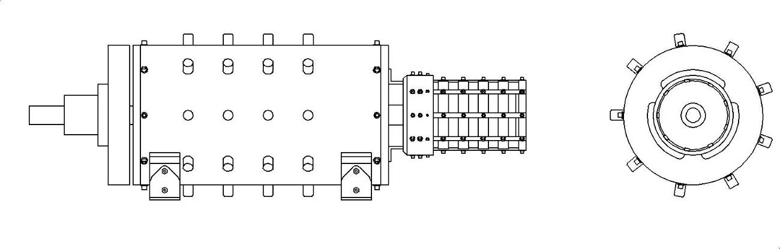
EMA6-E2 – 9 Pole Engine (May 1976)

Few men would resume operations in any business venture that went as bad as this one did. Both men must have had an un-wavering belief in the power of the technology they were pursuing to continue on. Gray didn’t have a complete picture of the technology while Hack probably had just a little more. Somehow these men were able to set aside whatever their differences that might have had in dealing with the blame (which there was lots to go around) for the financial disaster. They appeared to have continued ahead as a partnership with what they had at hand. Gray no longer had the money to pay Mr. Hackenberger.

Some where in LA Gray and Hack set up shop to rectify what ever mistakes they had made with the EMA6 design. They had only penny’s to work with. Hack was probably much more humble about his knowledge of the Cole Free-Energy process. At least he knew of one good idea (and probably several) that didn’t work. It is unknown if it was lack of time that lead to the poor performance of the EMA6-E1 and Hack knew this would happen well in advanced of the media event. Or, did he have a technical epiphany after the fact. The author votes for the second possibility, since there were several changes that were made to the EMA6-E1 that could have easily been done the first time around.

What ever the circumstances were, by May 1976 Hack and Gray were able to afford the fee to fabricate some retrofit components to remodel the EMA6-E1 and make it the EMA6-E2. The big change was the removal of the novel “CEST” devices and the addition of three additional plastic commutator rings. The multi-contact aluminum commutator seen at the media event had also been removed. There may have been additional changes that were internal to the engine itself.

In the photos below Gray is attempting to convince GD that improvements have been made to the engine such that it is now generating 500 watts of power (2/3 HP), which is operating the incandescent lamps in the background. The 2” wide leather belt that Gray is pressing down on makes a ¼ wrap around the engines’ shaft. The lower end is supporting a 50 lb weight while the other end is connected to a small spring scales (like a fish scales) connected to the table in the background. This setup is a simple method used to measure the energy output of the engine, however it can only be used for short periods of time and at low energy levels (less than 3 HP) before the strap heats up and starts to smoke.

There is another interesting photograph in the GD photo collection (not shown in this paper) that shows a Tektronix 4904 oscilloscope being used to aid in the retro-fit. This is the only photo that has ever been shown where any advanced electronic instrumentation was being use.

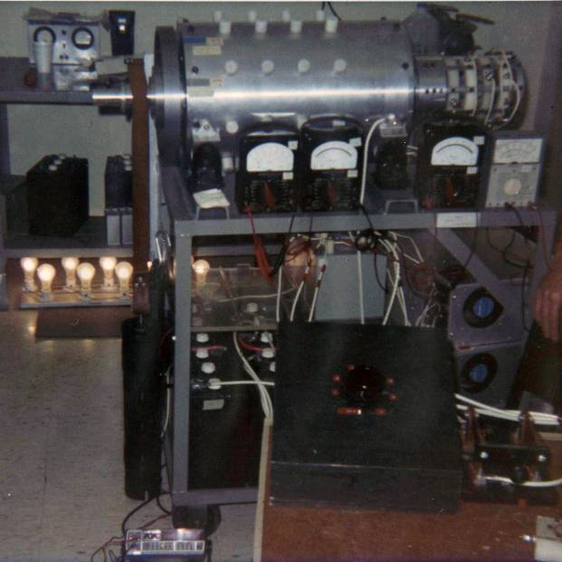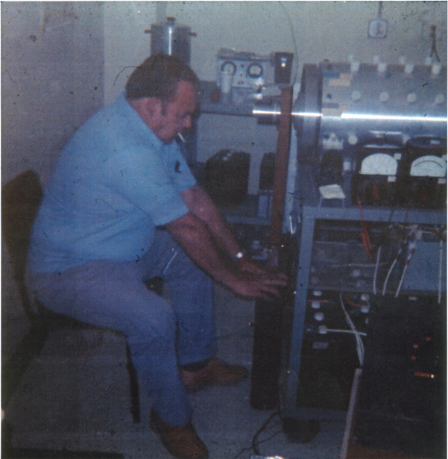

These photos were taken by GD May 14, 1976. This was the last time GD was able to document any further adventures with E.V. Gray and company. This is the modified EMA6 to become the EMA6-E2. Notice the addition of the three white commutator sections at the front of the engine (right side). The big observation to note here is the absence of the famed “CEST” devices. It is this author’s contention that they have been removed and functionally replaced by the new white “donuts” in the commutator.

In June of 1976, after the DA fraud case was settled, Gray was able to retrieve what was left of the EMA4-E2 (in boxes) after it had been run through the metal shredder. It is suspected that Hackenburger dug through these fragments and finally figured out what it was that he had over looked. What ever he found lead to yet another disaster just down the road. Some time in 1977 Richard got things to click and the machine came alive in the 50KW region. However, what ever he did was somewhat different that what was done with the EMA4. The result was a huge continuous burst of RF white noise that spanned several radio bands that lasted several minutes while Richard was congratulating himself on being able to figure out what it took to get this machine to come alive. He probably didn’t have a clue that he was generating such a powerful EMI signature, since it was never a problem with the EMA4, then again he didn’t know about the anti-gravity phenomenon that caused Marvin Cole to bolt.

In LA during 1976 this kind of event didn’t pass unnoticed by the authorities who are charged with policing the airways. It took them about 2 minutes to get an accurate fix on the source of the disturbance. The very next day two truck loads of armed FBI agents showed up and didn’t even knock. They didn’t even present a warrant. Apparently the War Powers Act of 1941 gives the FCC unmitigated storm trooper authority to do what ever it takes to put an end to any source of unlicensed RF energy. They took everything; the EMA6, the tools, the drawings, the file cabinets, Hack’s soldering gun, and the borrowed coffee pot. Nor were they polite about it.

It is unknown just how this issue was resolved. Both men could have been hauled off to prison for life if the FCC wanted to. There probably was a substantial fine involved as well (that didn’t get paid). It probably became clear to the FCC & FBI that these two men were just crackpot inventors and not commie terrorists. The parting message (as recounted by Nelson Schlaft) was straight to the point. “Don’t ever work on this again. WE WILL BE WATCHING”. Some say this event proves that the MIB were involved in suppressing this technology. Actually this is just the run-of-the-mill treatment any tax paying citizen would receive when bucking the establishment in matters of unregulated RF transmission in excess of a few milliwatts. Researchers should keep this in mind. If you are working with this technology and are producing arcs for more than a few seconds, then have a couple of transistor radios close at hand tuned to three separate and widely placed channels (AM, FM, and UHF). Pay attention to how much noise is being picked up and take preventative measures as needed, or else all of your efforts will be hauled off to the local incinerator. You may or may not have to pay a fine and show up in court but you will definitely be told “Don’t ever work on this again. WE WILL BE WATCHING”.

Gray’s office equipment was eventually returned, covered with FBI evidence stickers. Anything that looked electronic was immediately destroyed. Later on Gray was much more concerned about EMI when working in Canyon Country in 1980. Nelson Schlaft reported that when he was working under Gray’s engineer at the time he was instructed to go out and buy 100’ of ½” EMT conduit to fabricate shields for the circuit they were working with at the time. It turned out to be a real plumber’s nightmare, but there was a genuine purpose behind this absurdity.

Meanwhile Gray and Hack were getting to be down right experts at this raid and confiscate thing. Surviving one humiliating outrage like that is difficult. Surviving two such assaults speaks of an un-dying faith in what they were attempting to accomplish, to make matters worse they were just so close that time. Perhaps Hack consoled himself in knowing that he had finally figured out the deceivingly simple system that Cole had left behind. The FBI could take the equipment but they couldn’t take what he had finally learned – the hard way. The irony of this event is that the FCC didn’t have a clue as to what they were disposing of. A simple engineering review as to just what had caused such an anomalous RF disturbance without a substantial antenna might have opened up a new page in history, but bureaucrats are not known for thinking like that.

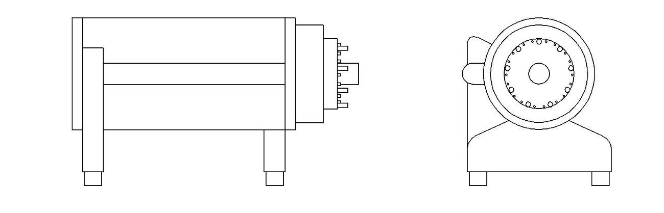
EMA7 – 9 Pole Engine “The Blue Engine” (1979)

Gary and Hack continued on. Somehow Gray was able to re-establish a connection with a businessman he knew from Kalona, Iowa who owned a large trucking company. In the early 70’s Gray made a number of business tours through the Corn Belt region. His 2nd wife Renate had family connections with a number of church organizations in that area. The idea was to simply sell stock in Gray’s company. Several demonstrations were held during church coffee hours. Whatever it was that Gray had to make his presentations it won a lot of converts. One of them was the businessman Russell Audrey. It is unknown how the original contact was made, but apparently the failure of the EMA6 at the media event didn’t seem to bother him (perhaps he wasn’t there). When he was called upon to consider a new business opportunity he was very interested.

Russell Audrey was not interested in an automobile engine. His market vision was the need for inexpensive irrigation pumping. It takes about 1 HP of pump to water 1 acre of flat corn field. That means a lot of energy is involved in the production of corn. The cost of electricity for running those pumps is the most costly expense in attempting to make a profit in corn farming. A Free Energy-Engine would be an age changing benefit to the entire region, not to mention a very profitable investment for Mr. Audrey. He invested heavily into the E.V. Gray vision. It appears that he was heavily criticized by his family for doing so. Every dime he spent on snake-oil research was one less dime they stood to inherit. Several calls to relatives were never returned in searching for additional historical facts.

According to Mark Gray, himself, his father, and Mr. Hackenberger, all loaded up the company van and traveled half way across the country to setup shop for 18 months in a facility provided by Mr. Audrey. They lived in a motel while doing a number of things that Mark didn’t understand. Then on Christmas Eve 1979 Mark Gray was told, by his father, to quietly load up his personal things and get in the truck as the trio quickly left town in the middle of the night. The company truck had already been loaded with whatever equipment Gray and Hack wanted. They took turns driving and made a non-stop bee-line to San Diego, CA. It was very cold and Mark Gray recalls how Hack was having problems attempting to get the gas nozzle into the tank hole. He was probably exhausted from the stress and got chilled during the getaway. In two weeks he would be dead from some kind of rapid onset flue.

It would appear that the deal cut with Mr. Audrey went sour somehow. But, before the trio left town something important must have happened to want to leave in the middle of the night with stolen hardware. It has been speculated that Richard was finally able to figure out what he didn’t know the first time around and was able to put it all together on the next try. It is assumed that his last creation, and the last Free-Energy Engine, was built in Kalona then brought back to California.

Gray hid out in San Diego for about 6 months. He then found fresh funding from two business men from the Jewish community. He then went to Canyon Country, CA (NE of LA) and set up a business front called “American Home Health Care”. He still had a lot of people looking for him, mostly collection agencies. But he also had a very angry Russell Audrey searching for him with a court order in hand as well. For these reasons most all of Gray’s marketing efforts were directed towards overseas customers.

Gray once again had a somewhat working Free Energy Engine in his possession that just needed “a little more work”. In all this time he still didn’t understand enough physics or electronics to carry on actual technical development himself. His plan this time was the same as the last time, when his engineer died or disappeared; he just hired another one off the street. This is how Nelson Schlaft came into the picture. He was hired from a news paper ad looking for a job as an electronics technician.

The business saga of Mr. Gray’s adventures continues on from here for another decade, but this was the effective end for any further Free-Energy Engine advancements. As was mentioned before, Nelson Schlaft butchered the old Pulse Motors as part of his job to make them rotate for the video camera, including the new “Blue Engine”. It is hard to believe that Mr. Gray’s technical understanding was so weak that he was unaware of what was going on. The loss of the historic Pulse Motors was probably not too big of deal. But the loss of Richard’s “Blue Engine” was heart stopper – and Gray appears to not have been aware of the situation.

We know almost nothing about the “Blue Engine” or the EMA7. It can easily be distinguished from the Pulse Motor era from the number of protrusions on the commutator. This is a 9-Pole machine with contact spacing very similar to the EMA6. What is interesting is how Richard was able to make this design so much more compact. It’s about 9” in diameter and 18” long. No doubt he used permanent magnets for the rotor. To bad we don’t know any more about its performance. It would be interesting to examine its internal structure and note the approaches used in the electrostatic harvest sub-assemblies.

Whatever Richard accomplished during his last days of working for Russell Audrey he must have thought it was important enough to steal and risk his health in the process. Unfortunately, what every combination of components that Hack was able to get to work were still not simple enough for an off the street technician to figure out – let alone understand or advance without documentation.

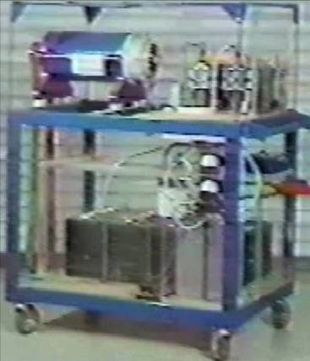

A frame capture from the 1986 Promotion video showing what is thought to be the EMA7 aka “The Blue Engine”. This engine is believed to be the smallest Free-energy Engine ever built and the last. A close look at the front commutator with revel enough contacts to support 9-Pole operation.

Conclusion:

This lost technology is important as well as powerful. There are many reasons to believe why this approach was real and valid. There are but a few non-classical technologies known that even come close to the power levels and COP’s observed/measured with the Cole/Hackenberger Free Energy Engines. What is more important is that all of the materials can be purchased from McMaster, Mouser, and Granger catalogs. But don’t kid yourself; this is not a simple system. Reverse engineering what was, from what is left, is a formable task. So little is known about just what Marvin Cole had under the hood, let alone any sort of operational theory.

For the past decade non-funded researchers have been unable to come to a general consensus as to where the non-classical process actually takes place. Some have focused on the design of the power supply, some have made replication pulse motors, and many have explored various designs of the “Converter Element Switching Tube”. So far (Dec 2010), no one has publically reported any substantial success. There are a handful of blogs and forums that discuss this subject on the Internet.

Everyone who prospects for a solution to this story pans for inspiration in their particular gulley of ideas. Perhaps this paper will provide just enough additional information for someone to put the whole story together.

Additional References Mostly from Peter Lindemann's Website

1 - Source Documents in the Public Domain

Patents

• #3,890,548 - June 17, 1975; Pulsed Capacitor Discharge Electric Engine http://www.pureenergysystems.com/os/EdGrayMotor/PM_PEM_MG/patents/3890548/index.html
- #4,595,975 - June 17, 1986, Efficient Power Supply Suitable For Inductive Loads http://www.pureenergysystems.com/os/EdGrayMotor/PM_PEM_MG/patents/4595975/index.html
- #4,661,747 - April 28, 1987, Efficient Electrical Conversion Switching Tube Suitable For Inductive Loads http://www.free-energy.cc/pdf/US04661747__.pdf

Articles
- Short Biography of Edwin Gray From by Dr. Peter Lindemann http://www.free-energy.cc/graybio.html
- Man Creates Engine That Consumes No Fuel; The National Tattler, July 1, 1973, by Tom Valentine http://www.free-energy.cc/images/Img0002.jpg
- Miracle No-Fuel Electric Engine; The National Tattler, July 8, 1973, by Tom Valentine http://www.free-energy.cc/images/Img0001.jpg
- The Engine That Runs Itself; Probe The Unknown, July 1973, by Jack Scagnetti http://www.free-energy.cc/images/Probe1.jpg
- Smog-Free Engine Ignored; Los Angeles Free Press, December 28, 1973 http://www.free-energy.cc/images/SmogFree1.jpg
- 2 Inventors Work To Devise Fuelless Car; The National Tattler, January 23, 1974, by Tom Valentine http://www.free-energy.cc/images/2inventors1.jpg
- Inventor of World's First No-Fuel Engine is Suppressed by LA District Attorney; The National Tattler, March 16 1975, by Tom Valentine http://www.free-energy.cc/images/WorldsFirst1.jpg
- Auto Motor Inventor Just Fueling Around?; The Progressive Bulletin, July 7, 1975 http://www.free-energy.cc/images/AutoMotor1.jpg
- EMS- Electronic Power That Could Change The World's Economic Power Picture; Newsreal, June 1977http://www.free-energy.cc/images/Newsreal1.jpg

References Continued

2 - “Technical Discussion” by Richard Hackenburger http://www.pureenergysystems.com/os/EdGrayMotor/PM_PEM_MG/TechnicalDiscussion/RichardHackenberger/index.html

3 - “The Engine That Runs Itself”; Probe The Unknown, July 1973 by Jack Scagnetti http://www.free-energy.cc/images/Probe1.jpg

4 - John Bedini’s E.V. Gray Field Notes, 1979, 1982, 1984 personal notes released to the common domain. Available from the KeelyNet of John Bedini’s web site.

5 - “The History of the E.V. Gray Motor” – 2 hr presentation by Norman Wooten
KeeleyNet Conference 2001 – June 16-17 – Dallas, Texas

The History of The E.V. Gray Motor by Norman Wootan - 2hr VIDEO
The truth is finally revealed. The mystery about Ed Gray's EMA motors is finally over. With two recovered EMA motor prototypes on stage at the KeelyNet Conference in June 2001, Norman Wootan discusses every design feature possible. Every single way the real motors deviate from the designs revealed in Gray's Patent are discussed in detail. Now you can see with your own eyes how it was really done. This video is a must for serious researchers wanting to convert Radiant Energy into mechanical power. A great companion piece to "The Free Energy Secrets of Cold Electricity" by Dr. Lindemann (book or video) where the EMA power supply is discussed. (2 hrs.)
http://www.free-energy.cc/products.html

- “The Secrets of Cold Electricity” by Peter A. Lindemann, D.Sc.

The Free Energy Secrets of Cold Electricity by Peter A. Lindemann, D.Sc.
This book explains how Edwin Gray produced "cold electricity" and how that relates to Nikola Tesla's discovery of "Radiant Energy" over a century ago. All of the images that appear as slides in the video are reproduced in the book, as well as complete reprints of Edwin Gray's three US patents, and three of Nikola Tesla's US Patents, which related to the subject. This is an important study manual for serious researchers. Ed Gray's EMA motor produced 40 times more power than he took from his batteries. The secret is in the power supply and this book tells how it works!
http://www.free-energy.cc/products.html

- “Power Electronics – Converters, Applications and Design” 1989 Mohan, Underland, Robbins, Wiley & Co.

8- “The Mye Technical Manual” Section 4 - Vibrators and Vibrator Power Supplies, by Mallory
Co. available from Radio Era Archives at http://www.radio.com

